Marchant Wentworth
Environmental Advocacy --- Research

Testimony of

Marchant Wentworth
Principal
Wentworth Green Strategies

Submitted For the Record Oversight Hearing on DC Water Before the
Committee on Transportation and the Environment District of Columbia City Council
March 2, 2026

903 Hamlin St NE, Washington, DC 20017, marchant_wentworth@msn.com, 202-735-7104!

Abbreviations
BPWWTP - Blue Plains Wastewater Treatment Plant CD - Consent Decree
CSO - Combined Sewer Overflow
DOEE - District Department of Energy and the Environment EPA - US Environmental Protection Agency
GI - Green Infrastructure
JBAB- Joint Base Anacostia Bolling LID - Low Impact Development LTCP -Long Term Control Plan MG- million gallons
MGD - million gallons a day NEB-Northeast Boundary Sewer NPS - National Park Service

Mr. Chairman and Members of the Transportation and Environment Committee:
I am Marchant Wentworth, Principal, Wentworth Green Strategies. Thank you for the opportunity to submit this testimony for the record for the oversight hearing on DC Water.
Previously, I was part of the multi-year stakeholders process to create the Long Term Control Plan to control combined sewer overflows (CSOs) into the waters of the District of Columbia. Since the first consent decree was lodged in federal court in 2002, I have remained an avid student of DC water pollution issues.¹
This testimony is divided into three parts: the first is a brief history of the DC sewer system. That is followed a more detailed discussion and recommendations concerning the sewage spill of January 19, 2026. The final section is devoted to the combined sewer overflows of the Potomac River.

Background and Brief History

Overall, DC Water is a well-managed organization. DC Water operates the world's largest advanced sewage treatment plant to great acclaim - and consistently well within limits set by EPA. DC Water has received clean audits for 29 years and maintained high bond ratings that have saved ratepayers millions of dollars.
Their effort to capture the sewer break and minimize the environmental impact of the sewage spill of January 19, 2026 was, by any measure, extraordinary. All those who care about and recreate on the Potomac are thankful for DC Water's prompt and professional response to the sewage spill. While there are valuable lessons to be learned from the response to the spill that will be discussed later, overall DC Water is to be highly commended for their prompt response.

History and Background

A Brief History of Sewers in the District

Even in the late 1800's, it did not take an expert to know that District's sewage system wasn't
working. For over hundred and thirty years, between the establishment of the City in 1800, and

1 My comments, including prior testimony, can found at my website: www.wentworthgreenstrategies, com

the construction of the first treatment plant in 1935, most of the District's sewage was directed into the Washington Canal, a fetid ditch running from the base of the US Capitol to the Potomac and its flow subject only to the tides.2The rest flowed into the Anacostia through a huge outfall just south of the site of RFK stadium. Waves of cholera and malaria, originating from contaminated sewage flats on the Potomac and the Anacostia periodically swept through the city.³
Alexander "Boss" Shepard. DCs Mayor in the 1870s, engaged in a wild flurry of sewer construction, largely devoted to furnishing sewers to his real estate cronies and political friends. Then, sensibilities around pollution were quite a bit different than today.⁴ Then the adage "the solution to pollution is dilution" was in full sway. Engineers used the combined sewer designs popular of the age that constrained sewage to a trough within a larger pipe. They computed that the offensive overflows would only occur when there was as much as three times the amount of stormwater as wastewater, theoretically making pollution impact on the stream, in their eyes, relatively minor.
But although they were relatively cheap to build, there were a number of problems with combined sewers. For one thing, under pressure from real estate speculators, rapid development occurred in the District, particularly between the First and Second World Wars, that brought armies of office workers to town. This flood of folks overloaded the sewer system originally built to accommodate a much smaller population. An other problem was that in response to the needs of rapacious developers, pipes were laid with little mind as to where the sewage was gomg.

2 The original grand vision for the Washington Canal was to enable canal commerce to the city and provide a ceremonial entrance for the White House. The Canal rapidly silted and was covered over and converted to sewer by Mayor Alexander "Boss" Shepard in 1887.
3 To escape the pestilence, by the 1880s, many of the wealthier residents fled to the higher elevations such as Mt.
Pleasant, Cleveland Park, Brookland, and Anacostia Heights.
4 Most historians agree that Mayor Shepard's sewer system was a disaster. Pipes often lacked even a nod to the basic principles of hydraulics. Apparently built to mainly satisfy his friends in the real estate industry, Shephard's sewers, even when they worked, typically just drained into the Washington Canal, already a dangerous fetid ditch that periodically flowed with the tides to form the malaria laden swamp flats adjacent to the present site of the Lincoln Memorial. Small wonder that many presidents decamped to higher and less dangerous suburbs especially
during the dank humid days of Washington summers.

In response to the ongoing pollution, the stench, and malaria and cholera that accompanied it, President Harrison convened a special panel to review the situation and recommend improvements. The "Hering Report," released in 1907, contained all the key elements for the creation of the present-day sewer system.
One response to the Hering report was that the city started building separate systems for wastewater and stormwater. Generally speaking, this meant that newer portions of the District, particularly the White middle class parts, received separate sewers⁵ while the older (and Blacker) portions of the city, generally the city south of Florida Ave and stretching east past Capitol Hill to the Anacostia River, remained on the combined system. In total, approximately three-fifths of the District is currently serviced by combined sewers.⁶
Other ideas contained in the Hering Report included the construction of large interceptor sewers to intercept or block sewage from flowing into Rock Creek, the Potomac and the Anacostia and the all-important siting of a treatment plant downstream from the city. All that remained was to gain the funding to actually implement the improvements. That effort would take over a century.
A treatment plant was finally built by New Deal funds in 1935 but was overwhelmed even as it was built. The under-capacity treatment plant was routinely forced to discharge its load with minimal treatment back to the Potomac River. This had devastating results. Fish died. The Potomac stank.

5 In a separate sewer system, sanitary waste is carried in a separate pipe from stormwater.
6 There are exceptions. Southwest, whose old neighborhoods were leveled to accommodate "urban renewal" for white affluent residents, were reconstructed with separate sewers. And for reasons that are unclear, most of the Anacostia neighborhoods east of the River, received separate sewers.

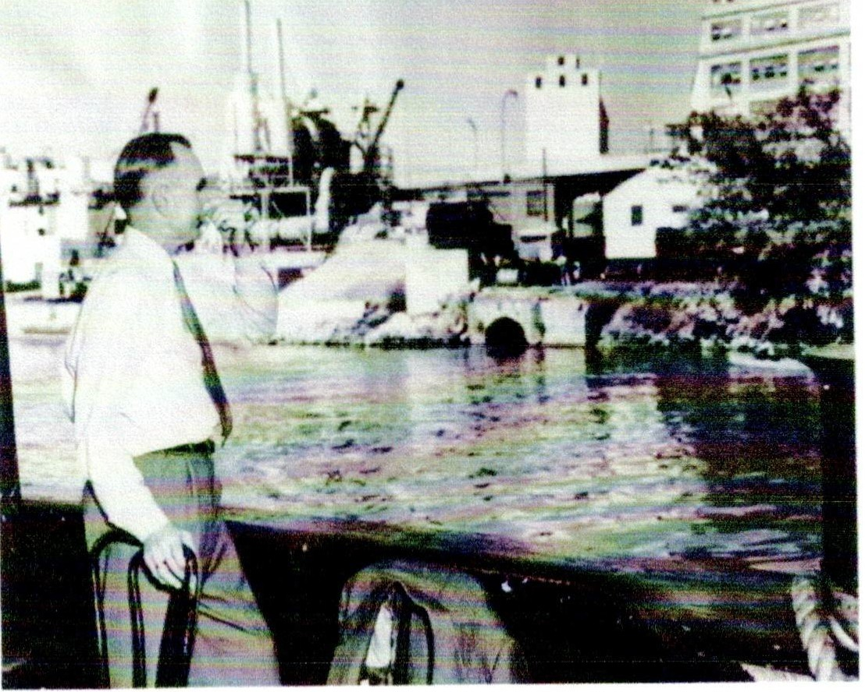
-
Figure 4. Sen. Wayne Morse (D-OR), holding his nose against the stench of the Potomac with CSO 22 in the background. Circa 1955. Courtesy of the Interstate Commission on the Potomac River Basin.

Developers in the suburbs created ever more housing with little care that there were inadequate treatment facilities at the other end of the pipe. This provoked a sewer moratorium for the surburban counties tributary to the treatment plant. To gain relief from the moratorium, in the guise of providing service to the new Dulles International Airport, developers, aided by their friends in Congress (DC had no vote and no say in the matter), gained federal funding in 1960 for a 54 mile sewer line⁷ that could service their planned development along the Dulles Toll Road. But the sewer system in the District was not designed for these additional flows. By 1972,

⁷ In a project that would hardly be tolerated today in the world of environmental impact statements, the Dulles Interceptor pictured above was actually sited in the bed of the C & 0 Canal in the midst of the C & 0 Canal National Park. Rep. Joel Broyhill (R-VA) and his friend "Till" Hazel, an influential developer, were likely the prime movers for the project. The US Army Corps contracted to build the Potomac Interceptor but the District had little or no say in the matter.

the result was a 23 million gallon a day (mgd) overflow at CSO 24, adjacent to the Thompson's Boat Center in Georgetown.
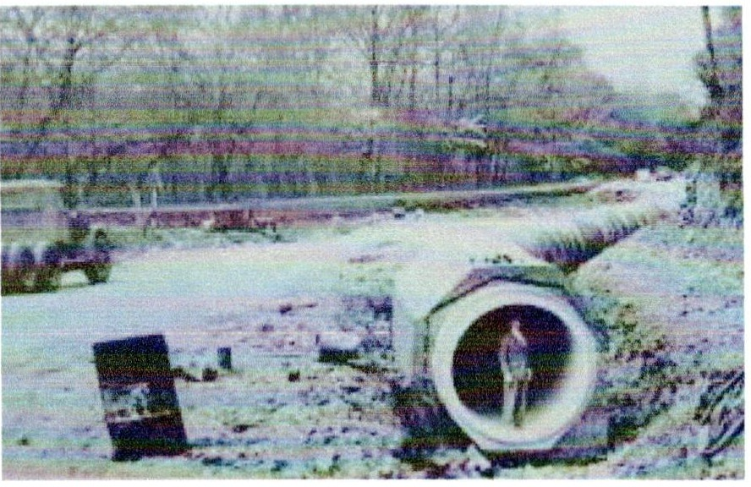
FIGURE 1 THE CONSTRUCTION OF THE POTOMAC INTERCEPTOR IN THE BED OF THEC& 0 CANAL CICA 1962 .

By the 1950's, huge floating algal mats formed as far upstream as Georgetown, making pleasure boating hardly a pleasure. Instead of opening just during rain storms, some of the overflows, connected to pipes far beyond their capacity, flowed constantly. Adding to the problem, the District's Department of Sanitary Engineering, was perpetually behind in badly needed maintenance of the system, due to lack adequate of appropriations from pre-Home Rule Congress⁸, coupled with politicians siphoning off money from the Sewer and Water Fund. And the Potomac, Anacostia and Rock Creek paid a heavy pollution price. After urging from environmental groups and public health experts, in 1972, the DC Council banned any bodily contact with all of them.
Despite generous grants under the New Deal in the 1930s that funded various trunk sewers and the all-important treatment plant, what was desperately needed was a reliable funding source. That didn't arrive till 1996 with the federal legislation that created the independent DC Water and Sewer Authority, now known as DC Water. This new agency had the authority to issue bonds that could supply the funding to modernize the system. It also could protect the agency from the periodic raids on the Sewer and Water Fund by politicians.

8 For years, District appropriations was completely dominated by Rep. John C. McMillan (D-SC), chairman of the House District Appropriations Subcommittee who persistently under-funded the District.

The new independent authority was created because activists, big water users, such as office and apartment buildings, and politicly powerful suburban water and sewer clients who were fed up with a underfunded sewer department and a grossly polluted Potomac, asked Rep. Tom Davis (R-VA ) to craft a bill creating an independent agency that would put funding out of the reach of greedy mayors. He not only wrote the bill but adroitly shepherded it through Congress. The result was a federal law, signed in 1996, that created an independent agency that could hire and fire staff and-most importantly -- issue its own bonds.
This ability of the new independent agency, the DC Water and Sewer Authority (now called DC Water) to raise money has led to numerous improvements over the always-struggling District Department of Sanitary Engineering that it replaced. It also created somewhat of a conflict for the new utility: how to balance the need to upgrade DC's ancient sewer and water system through their Capital Improvement Program (CIP) versus the need to keep borrowing and operating costs to a minimum, preserving high bond ratings and low interest rates and ultimately keep water rates low.
While the new Authority modernized the Blue Plains Advanced Wastewater Treatment Plan, there remained the problem of combined sewer overflows polluting the Anacostia, Potomac and Rock Creek. It took a citizen suit filed in October, 1999 from the Anacostia Watershed Society, the DC Chapter of the Sierra Club, the Canoe Cruisers Association, and a band of other clean water advocates ably guided by the legal wizards at Earthjustice to force action to clean up the combined sewer overflows that have plagued our waterways for over a century. Later joined by EPA and the Justice Department, the consent decree signed in March, 2005 to settle the lawsuit mandated, among other things, the creation of the Long Term Control Plan (LTCP) to curtail the worse of the combined sewer overflows through, along with other initiatives, the use of massive 23 foot concrete tunnels that store the combined stormwater and sewage until after the rains and pump it to the treatment plant. A completed Anacostia Tunnel, now removes over 98 percent of the overflows. The comparable Potomac tunnel will be completed by February, 2030. This tunnel
will eliminate 93 percent of the combined sewer overflows by volume from all the Potomac CSOs (CSOs 20, 21, 22, 24, 27, 28 and 29). Under the terms of the Consent Degree, CSOs 25 and 26 were separated in 2022 and now have no sewage discharge to the River.

But until the Potomac tunnel is put into operation in 2030, seven of the Potomac overflows will continue to discharge combined sewage and stormwater into the Potomac and are the subject of the third section of my testimony.
To put these discharges into perspective, in a single year, 2021, Potomac CSOs disgorged over 879 million gallons a day into our Potomac River, vastly exceeding the 243 million gallons of sewage from the sewage break of January 19, 2026.

Race and Sewers in Washington

No discussion about our sewage system in the District is complete without at least a mention of race. The effects ofracist and miserly appropriations from the pre-Home Rule Congresses directly resulted in the vast differences in treatment and outcomes for the Potomac and the Anacostia.⁹ The Potomac got a floating barge featuring symphonies and musicals. The Anacostia got the NE Boundary Sewer, the dirtiest outfall in the system, that spewed millions of gallons of raw sewage daily into the river. The Potomac got the Kennedy Center for the Arts and Thompson's Boat Center for rowers. The Anacostia got Langston Golf Course and the Kenilworth Aquatic Gardens. But even these were tarnished by the Kenilworth Dump that was only shut down in the 1968 after a seven year boy was burned to death when the ever simmering fires of the dump turned on him.
These racial disparities are just starting to be addressed after a more than a century of enforced White ignorance. DC Water's successful Clean Rivers Program has cut CSO pollution in the Anacostia by 98 percent and promises to do the same for the Potomac when the tunnels are completed in 2030. With the discharges now captured by the Anacostia Tunnel, attention now shifts to cleaning up the sediment contaminated through years of illegal discharges of toxics and other environment insults.
Literally dozens of organizations ranging from the stalwart Anacostia Watershed Society and the Anacostia Riverkeeper to the Anacostia Waterfront Trust, DOEEs Anacostia River Sediment Project, and the Anacostia Watershed Restoration Partnership, groups both within and outside the government, are all now actively working to reverse the decline of the Anacostia. It took more than a century to despoil the Anacostia. Restoring it will take time.
My deep appreciation goes out to all the staff and volunteers that work on the Anacostia for their dedication and persistence.

9 The most complete historical treatment of the Anacostia is chronicled in Anacostia: The Death and Life of an American River. John R. Wennersten, The Chesapeake Book Company, 2008. Distributed by Alan C. Hood & Co. Inc. PO Box 775 Chambersburg, PA 17201 (Phone: 717-267-0867, toll-free, www.hoodbooks.com.)

Regarding the Sewage Spill of January 19, 2026

The horrendous sewage spill of January 19, 2026 highlighted some of DC Water's strenghs ---and weaknesses.

Recommendation: DC Water should create an in-house water quality sampling program that could supply the public with timely water quality information and provide a measure of success for creekbed rehabilitation programs.
Apparently it took until February 5, 2026, seventeen days after the January 19th spill, to reveaJ to the public the extent of the contamination downstream, even though DC Water's contractors had been sampling as early as January 29, ten days after the spill. Why the delays in sampling and informing the public?
The shocking fact is that despite being a world-class water quaJity centered utility, DC Water apparently has no water quality sampling capability of its own and must rely on contractors. This results in delays in supplying crucial water quality information to the public. This effort need not be duplicative. Having water quality sampling in-house would speed up the release of water quality data to the public in the event of the next inevitable sewer break. It would also enable DC Water to better measure success in its creekbed rehabilitation program and its restoration efforts in the Pinehurst and Fenwick sewersheds. DC Water should provide the Committee with a report describing how or if monitoring results are integrated into DC Water's Capital Improvement Program.

Recommendation: DC Water should work with their colleagues at the Interstate Commission on the Potomac River Basin (ICPRB) and the Council of Governments (COG) to create a comprehensive water conservation plan that could be quickly implemented for the users of the Potomac Interceptor to reduce the environmental impact of the next inevitable sewer break.
The sewer break has highlighted the fact that DC Water lacks any comprehensive water conservation plan to respond to sewer break emergencies. Even modest water conservation measures would have reduced the overflows to the Potomac River. But DC Water has been silent on the matter. DC Water should work with experts at the ICPRB and the COG to create a plan,

particularly for users of the Potomac Interceptor, that could be implemented quickly in the event of the next inevitable sewer break.

Recommendation: DC Water should streamline and strengthen the public relations department.
DC Water should be commended in its daily effort to issue updates. Prior to the sewer break, most inquires were directed to a single staffer, who then distributed queries to the relevant department. Prompt answers were not forthcoming. This department needs to be expanded. DC Water should work to reverse what some observers believe is a "circle-the-wagons" approach to communications. This is ironic because DC Water has lots of successes to report to the interested public.
In addition, DC Water should restart the tours of the Blue Plains Advanced Wastewater Treatment Plant to tell its success stories to the public.¹⁰

Recommendation: DC Water should work with their colleagues at the Interstate Commission on the Potomac River Basin (ICPRB) and the Council of Governments (COG) to create a comprehensive water conservation plan that could be quickly implemented for the users of the Potomac Interceptor to reduce the environmental impact of the next inevitable sewer break.
Both ICPRB and COG have a deep history of crafting innovative inter-jurisdictional approaches to regional problems. Both organizations have been aware of the need for regional cooperation on water issues for decades. Anticipating a reaction to the next sewer break would go a long way towards speeding the response and minimizing the damage.

¹⁰ The tours can graphically educate folks to be careful not to treat their toilet as a trash can by showing the magnitude of the treatment process.

Recommendation: DC Water should retain the services of a company that will independently verify the quality and extent of the cleanup and water quality at key areas of recreation.
Users of the Potomac, ranging from kayakers to waterman, are understandably skeptical of the clean-up effort. One way to instill more trust is to have an independent company verify the quality and extent of the cleanup, particularly on and around key areas of recreation and shellfish production.

The Combined Sewer Overflows (CSOs) of the Potomac River

The horrendous sewer spill of January 19, 2026 highlighted the fact that there are other pollution sources that degrade the water quality of the Potomac: combined sewer overflows.
According to the Long-Term Control Plan (LTCP), originally there are 10 CSOs along the Potomac. Of those, two have been separated, and one, the Joint Base Anacostia and Bowling (JBAB) is a minor discharger, and functions as a relief valve for the Anacostia Tunnel, and not the subject of this testimony.¹¹
Collectively, the seven CSOs examined in this testimony discharged 879.67 million gallons a day of mixed sewage and stormwater into the Potomac in 2021.
To characterize the CSOs on the Potomac River, this study made extensive use of the Quarterly Operations Report for the District of Columbia, prepared by DC Water, Department of Pumping and Sewer Operations. This report, available on the DC Water website by 23rd of the month following the end of each quarter, not only contains details on such things as the volumes of wastewater pumped, trash removal, and daily rain data, but, for the purposes of this testimony, it also contains the results of a computer model of the discharges of each of the combined sewer outfalls for each calendar quarter from the District's CSO system. Because the DC Water computer-generated data is a model, the discharge data and the accompanying graphs in this report may or may not resemble actual conditions. But the model has been verified with real time measurements and, viewed over the seven-year study period, the supply a reasonably accurate picture of the functioning of the CSO system.

¹¹ A more detailed examination of the Potomac CSOs is available in my report "The Combined Sewer Overflows of the Potomac" available on my website: www.wentworthgreenstrategies.com

What Are Combined Sewers?

The Combined Sewer - An Artifact of Sanitary Engineering

The combined sewer is an antiquated sanitary engineering artifact that attempted to solve the perpetual problem in sanitary engineering: how to accommodate the huge volumes of stormwater and wastewater as quickly and cheaply as possible and with minimal disruption to the neighborhood. The combined sewer system confined the wastewater to a central sunken channel in a middle of the larger pipe. (See Figure 3). During dry weather, as long as the sewage was contained in the channel, the wastewater flowed, usually by gravity, to our treatment plant. But during rainstorms, the pipes fill quickly and the sewage laden wastewater overtops its channel and flows into the nearest water course.

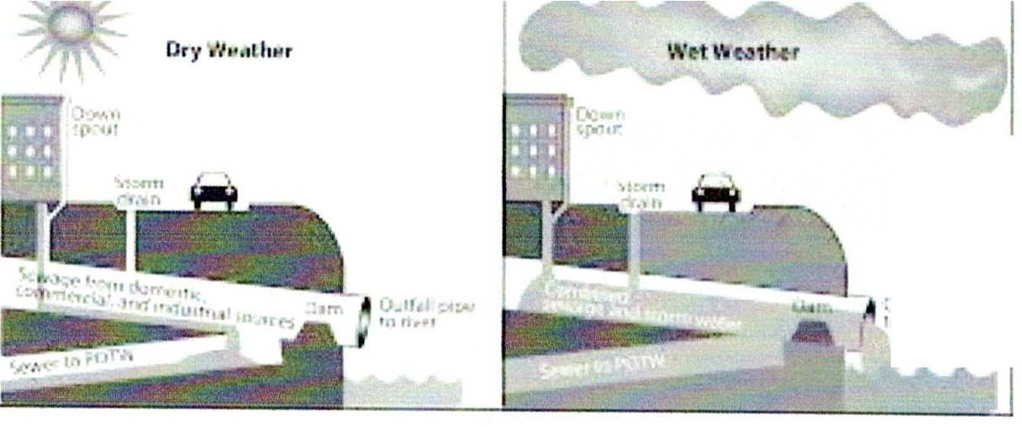
::,i:11 r,
1,1 ,I-
FIGURE 3. THIS SCHEMATIC ILLUSTRATES GENERALLY HOW CSOS POLLUTE NEARBY WATERWAYS

When It Rains - It Pours - A Preview of the Rains to Come?
On an otherwise unremarkable day on July 8, 2019, the US Women's Soccer Team won its 4th World Cup, Iran raised uranium enrichment levels, and it rained. At one point, meteorologists estimated it was raining 5 inches an hour. When it was over, the storm had dumped 3.44 inches on Washington National Airport - a one day record.
Three billion gallons of water fell from the sky. For those having trouble imagining that, it was the equivalent of 27 million hot tubs or 48,000 Metro rail cars. Avenues became creeks; Metro entrances, cascading waterfalls. When it hit our sewer system, the effect was dramatic. Fountains of sewage shot from manhole covers at 17th and D Sts NW and F St and Virginia Ave NW. CSO 12 near the baseball stadium gushed for almost three hours into the Anacostia. CSO #21 by the Kennedy Center overflowed for about an hour and a half into the Potomac. And CSO #34 near P Street Beach, discharged its load into Rock Creek for almost half an hour.
Clearly, this was no time to be in the water.
This extreme example shows us the worst that could happen. But climate scientists tell us this event is merely a preview of the future effects of climate change. Even now, a gentle summer rain produces a torrent of billions of gallons of storm water and combined sewer overflows in our often out of sight, out of mind sewer system.

Where the Combined Sewers Are and When They Flow We discuss each of the CSOs with a graph showing the discharges of their associated CSOs over the 2015-2021 study period. (See Table A, Appendix for the location of

Why Can't We Just Separate Our Sewers?

To separate combined sewers, crews dig trenches seven to ten feet deep, usually in the middle of the street, locate the offending pipes, and reconnect them to pipes leading to the treatment plant. This is a messy, expensive, and cumbersome process that is understandably not popular with the adjoining neighbors. It is best accomplished when the number of sewers that need reconnecting is relatively small or when utility work is
already scheduled for the location and the neighborhood disruption is already happening anyway. But even then it is hardly a happy time for the locals. In Washington,DC's historic Georgetown, for example, during work to realign and improve the 100 year old gas, electric and sewer lines, deadline after deadline slipped as crews ran into surprises digging into the century old infrastructure. Trendy shop owners howled about losing customers and irate (and often influential) Georgetown residents hammered on politicians to force the utilities to hurry up and get the job done. DC Water is understandably reluctant to undertake a similar sewer separation projects. Small wonder that they were eager to embrace a deep tunnel system a 100 ft. beneath the surface that would store the polluted rainwater and would be much less disruptive.
CSOs 21-29) (See also Table C in the Appendix which details the overflows by outfall for the period of 2015-2020.)
The total discharges of the 10 Potomac CSOs have increased over the seven years of the study period. In 2015, all the Potomac CSOs discharged over 555 million gallons of overflow to the river. In 2021, those discharges increased to 879.67 mg-over 36 percent (See Table A.) While varying rainfall maybe one contributing factor in the increase, (See Table 4), increases at individual CSOs such as CSO 20 and 21 have increased 119 percent and 56 percent respectively, whereas rainfall remained roughly the same.
Of the 10 Potomac CSOs, CSO 21, just upstream from the
· Theodore Roosevelt Bridge, contributed almost 62 percent of the overflows discharged to the Potomac over the seven-year study period 2015-2021 and over 82 percent more than the volume of overflow of the next dirtiest, CSO 20 located in sea wall just upstream from the Memorial Bridge (See Table C).
Seven of the discharges of the ten Potomac CSOs increased over the study period by over 50 percent. Discharges from CSO 20 and CSO 21 increased by 119 percent and 56 percent respectively. However, discharges from three Potomac CSOs decreased. The discharge from CSO 25 dropped 20 percent, CSO 27 discharges dropped 27 percent and those from CSO 29 dropped 13 percent. Rainfall variability in terms of quantity,

intensity and geographical distribution may be one factor in the variability of CSO overflow volume.
Ranked by volume of discharge (see Table C), the dirtiest CSO on the Potomac is CSO
21, upstream of the Theodore Roosevelt Bridge, followed by CSO 20, located in the sea wall just upstream of the Memorial Bridge. CSO 26, along the Georgetown Waterfront is the least polluting with discharges of only 8.72 mg during the seven year study period - and that due to an overflow in the single year-2021.

Recommendations
- Protect boating, recreational areas and other areas of possible contact on the Potomac. Institute comprehensive boater education progran1s to encourage swimmers and boaters to stay off the water during and a day after rainstorms when the sewers may still be running high. Boaters should observe the flashing warning lights over CSO 22 opposite the Watergate and at CSO 29, roughly 300 yards upstream from the Potomac Boat Club near Key Bridge.
- Reduce the volume of water going to the overflows. Institute pilot programs in vulnerable sewersheds including CSOs 24, 28 and 29, including such measures as comprehensive water conservation measures, enhanced green infrastructure at federal facilities and expanded stormwater retention programs.
- Anticipate the effects of climate change on the CSO system that, according to climate scientists, will increase the severity and frequency of rainstorms with concomitant increases in CSOs.
- Recreational users should be educated about CSOs. They should urge policy makers to reduce discharges.

In general, CSO discharges are largely dependent on the rainfall quantity and intensity although the amount of impervious surface in the sewershed plays a role. The overflows were most active during the unusually wet year of 2018. Overall, the annual Potomac CSO discharges ranged between 376 mg and 1,513 mg in the study period.
The Potomac CSOs are discussed starting from Memorial Bridge, then the CSOs adjacent to the Theodore Roosevelt Bridge, then Kennedy Center, the CSOs of Georgetown, including Key Bridge,and the Key Bridge Boat Rental and the Potomac Boat Club.

Potomac CSOs Location by Neighborhood
Memorial Bridge CSO # Location
- Approx. 300 yds. upstream from northwest end Memorial Bridge
Theodore Roosevelt Bridge CSO # Location
- Approx. 100 yds. upstream northwest end Theodore Roosevelt Bridge
Watergate
CSO # Location
- West bank Potomac opposite Watergate
Georgetown CSO # Location
- Approx. 10 yds. upstream Thompson's Boat Center; aligned with 30thand K Sts NW
- Aligned with 31st and K Sts. NW
- Aligned with Wisconsin Ave. and K Sts NW
- Aligned with 33rd and K Sts. NW
- Approx. I00 yds. upstream north side Key Bridge, adjacent to Key Bridge Boat Rental (a.k.a Jack's)
- Approx. 300 yds. upstream Potomac Boat Club; aligned with 38th St. NW

Memorial Bridge (CSO 20)
This CSO is the extension of the old B St Sewer that runs underneath Constitution Ave and contains the once mighty Tiber Creek that once emptied into the Potomac - or more accurately Potomac Flats, a malaria-ridden mire that extended from the outlet in Figure 3 to beyond what is now the east end of the Reflecting Pool. This is the second dirtiest CSO on the Potomac,

discharging a total of over 632 mg of combined stormwater and sewage to the river over the seven years in the study period. Situated in the sea wall immediately upstream of Memorial Bridge, CSO 20 had its largest discharge during the wet year of 2018, but very little overflows the previous two years.
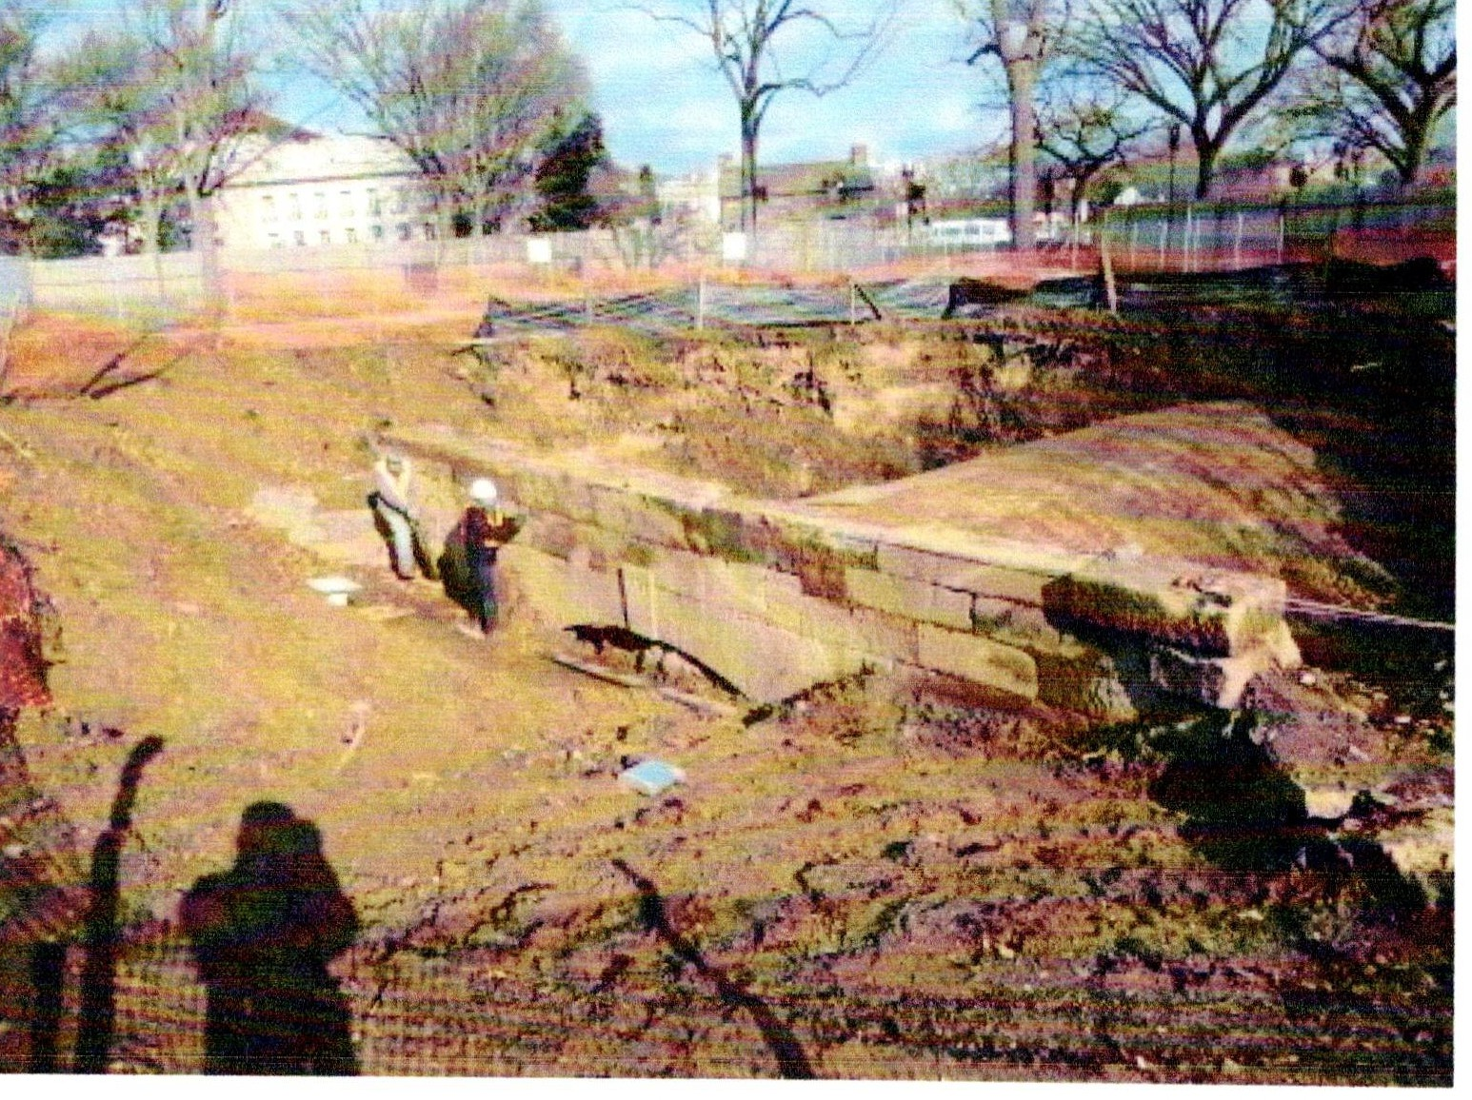

Figure 2. The original outlet for B St Sewer, now CSO 20, was revealed during construction around the Mall. Note the Lockhouse for the Washington Canal in the background.

The drainage area of CSO 20 extends for 573.14 acres, the largest drainage area of all the Potomac CSOs. It drains the area from the Lincoln Memorial, along Constitution Ave., north to F St. NW, along F St. to 10th St NW, proceeding north to O St. It then stretches west to Vermont Ave and south to Lafayette Square. This CSO includes the White House, the Department oflnterior, the Organization of Pan-American States, the World Bank and DAR Constitution Hall.
CSO 20 Discharge, 2013-2021 (mgd)

 | 2015 | 2016 | 2017 | 2018 | 2019 | 2020 | 2021
cso 20 | 55.8 | 1.39 | 2.59 | 204.65 | 78.15 | 167.75 | 121.93

,-...
Of)

250

200

CSO 20 Overflow 2015-2021 (mg)

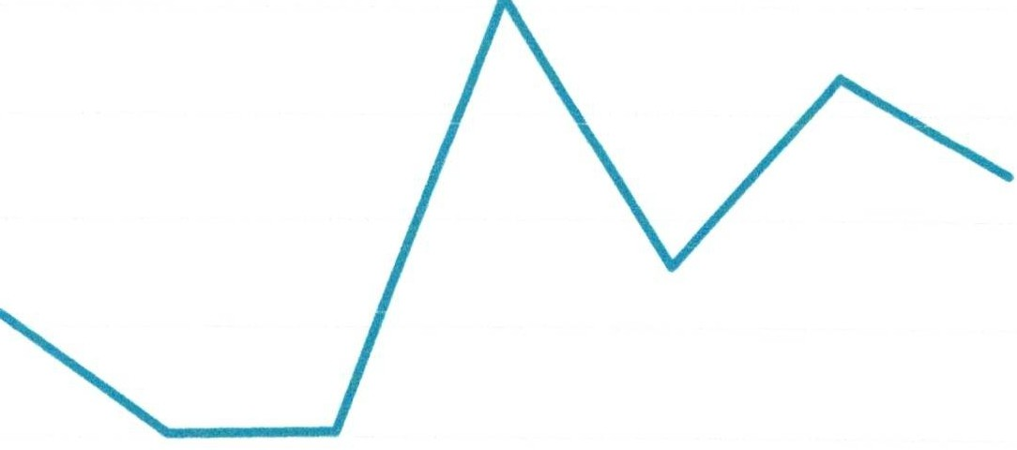
5150
Q)
Cl)
'-
c<S
-5
100
<J)
0
50

0
2015 2016 2017 2018
Year

2019 2020 2021

The Kennedy Center (CSO 21)

CSO 21 is mysterious. Not only is the actual outfall under several feet of water even at the lowest of tides, but its large discharge is in contrast with its rather small drainage area. During the seven year study period this CSO disgorged over 3,626 mg of overflow into the Potomac, the largest discharger on the River, almost 62 percent of all the Potomac CSOs combined, and over 82 percent more than CSO 20, the next largest discharger. Two bits of plumbing might explain the difference. First, CSO 21 appears to function as an overflow for the East Rock Creek Diversion Sewer that serves to protect Piney Branch Creek from excess flows from CSO 49 on Piney Branch in Rock Creek. Flows from the East Rock Creek Diversion Sewer may be reduced as work proceeds on the Green Infrastructure projects in the Piney Branch Sewershed and the 4.2 mg holding tank slated for the same area.
CSO 21 encompasses 473.78 acres, the second largest of the Potomac CSOs, and appears to be mainly confined to the Kennedy Center and a portion of the Watergate complex.

 | 2015 | 2016 | 2017 | 2018 | 2019 | 2020 | 2021
CSO21 | 340.78 | 309.14 | 518.86 | 876.81 | 339.35 | 709.22 | 532.36

Annual Discharge CSO 21 201�2021 (mg)

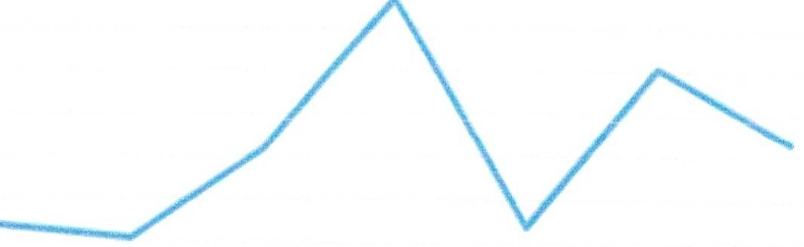
s:.:
,�
-
�v
�

1,'\ 3�0

: .. !5
ear

The Watergate CSO (CSO 22)

CSO 22 is one of the three CSOs in the DC sewer system graced with warning lights in the event of overflows. (The first is CSO 10, outside the Main Pumping Station on the banks of the Anacostia.The next is CSO 22, accoss the Rock Creek and Potomac Parkway from the Watergate and 10 yards downstream from the Thompson's Boat Center, and the third is CSO 29, 300 yds upstream of the Potomac Boat Club.) It is the third largest discharger of all the Potomac River CSOs.
The drainage area of CSO 22 - 125.23 acres-includes most of Foggy Bottom and the George Washington University campus. It extends from 26th St. north to L St. east to 21st St and south to F St. NW.

 | 2015 | 2016 | 2017 | 2018 | 2019 | 2020 | 2021
CSO22 | 54.39 | 19.06 | 46.58 | 141.84 | 66.78 | 131.8 | 88.24

OJ)
e

160
140
120

Annual Discharge CSO 22 2015-2022 mg

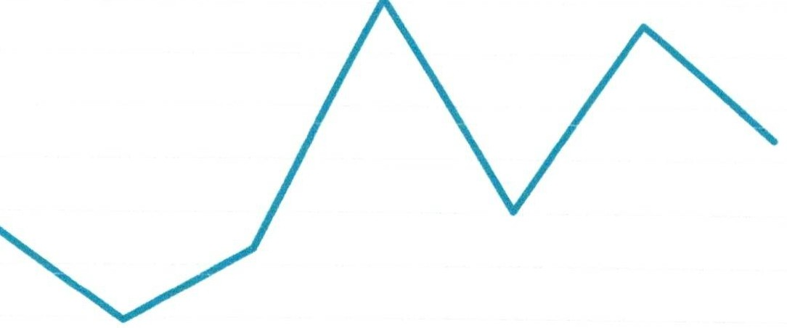
100
,u
� 80
i...u5c:I

60
40
20
0
2015 2016 2017 2018
Year

2019 2020 2021

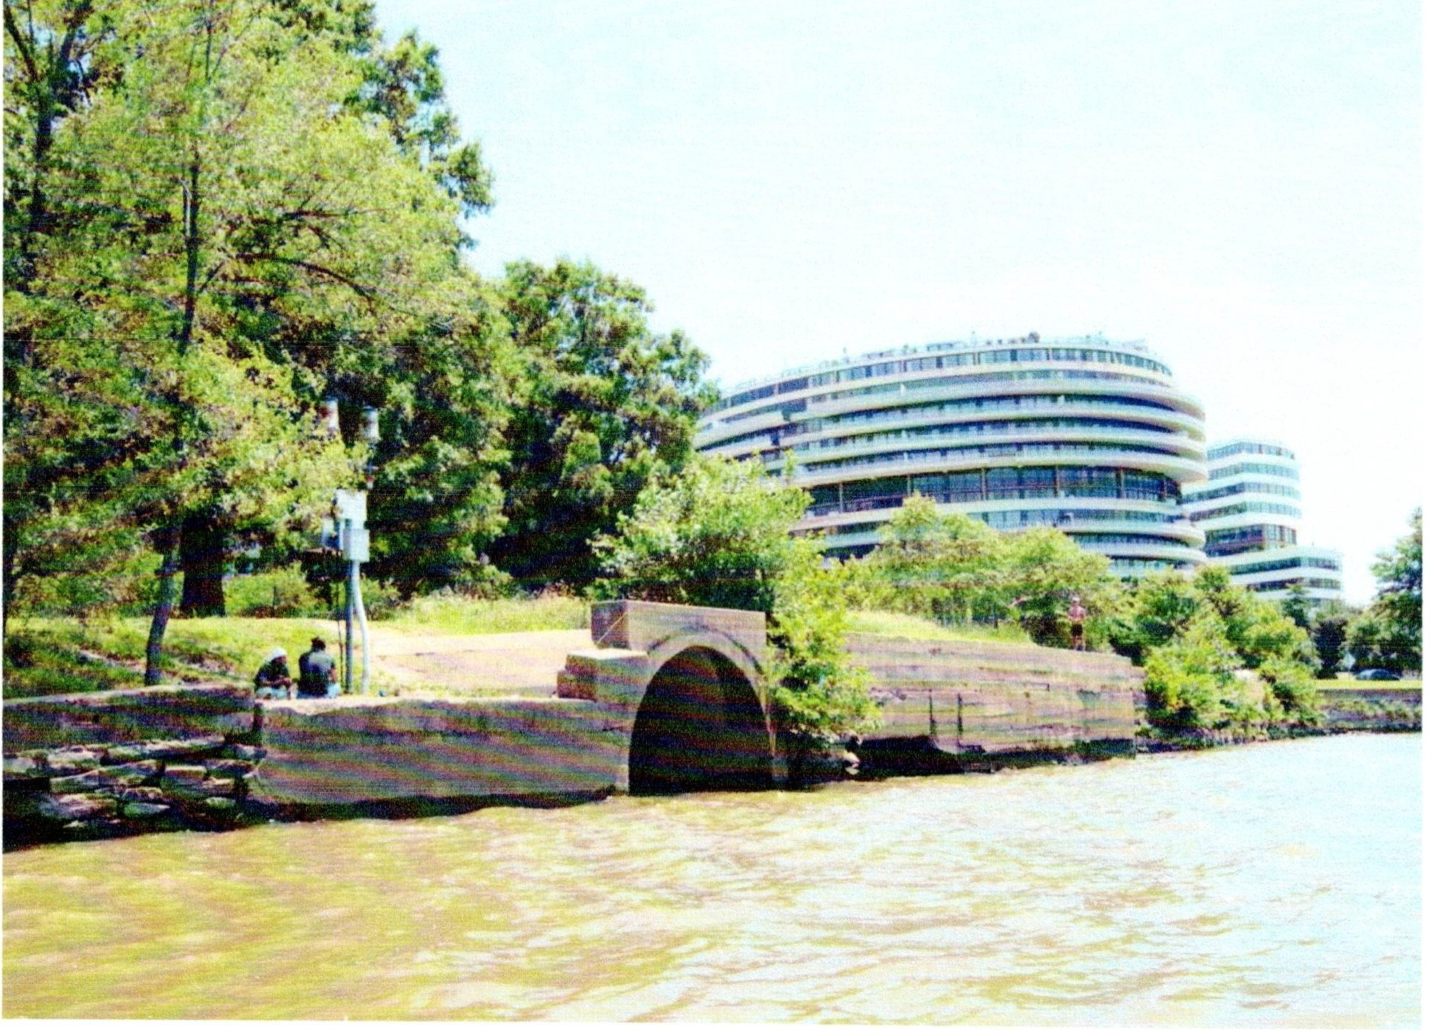
Figure 3. CSO 22, the third dirtiest of the Potomac CSOs, is immediately downstream from the Thompson's Boat Center. The lights that warn boaters of overflows are seen to the left of the outlet and next to two fisherpersons.

The CSOs of Georgetown (CSOs 24, 25, 26, and 27)

The four CSOs of Georgetown collectively dumped over 540 mg of stormwater laced with sewage over the seven year study period. Together these discharges made this collection of CSOs the fourth largest polluter on the Potomac. As you can see from the graph below, the CSOs were far from uniform. CSO 24,just upstream of the Thompson's Boat Center, topped the list at
305.79 mg. Barely flowing at all was CSO 26 at 8.72 mg at the base of Wisconsin Ave at
Georgetown Harbor.

The sewersheds for these CSOs extend throughout Georgetown for a total of only 244 acres.
The drainage area of CSO 24 is 41.66 acres and runs from the C & 0 Canal along the east of 30th St., south to K St., north to the north portion of the Swedish Embassy. The drainage of two of these CSOs - CSO 25 and CSO 26 - is no more than a few square blocks. This drainage area includes the west section of Georgetown Harbor, north on Thomas Jefferson St. to the C & 0 Canal, west on the Canal for 2 blocks to Wisconsin Ave., and south on Wisconsin Ave. to K St. Because of the compact nature of the drainage areas and the relatively small discharge, these CSOs are ideal candidates for sewer separation. This means that sanitary sewage is routed to new sanitary sewers and stormwater conveyed to the existing pipes to the river. That construction started in April, 2021 and is due to be completed by September, 2022. The drainage of CSO 27 -
179.38 acres - includes two sections. The first section runs west along the C & 0 Canal to Wisconsin Ave. and south to K St. The second part is a huge area encompassing all the shops along M St from 34th St west to Wisconsin Ave. and north to R St.

 | 2015 | 2016 | 2017 | 2018 | 2019 | 2020 | 2021
cso 24 | 37.40 | 17.40 | 25.69 | 77.54 | 32.36 | 67.24 | 47.76
CSO25 | 1.38 | 0.80 | 0.87 | 1.22 | 0.75 | 0.99 | 1.11
CSO26 | 0 | 0 | 0 | 0 | 0 | 0 | 8.72
cso 27 | 41.79 | 13.1 | 13.83 | 53.12 | 28.15 | 41.68 | 30.75

90
80
oJJ 70
E 60
�)50
_g 40
-� 30
Cl 20
10
0

Annual Discharge CSOs 24, 25, 26, and 27
2015-2021 mg

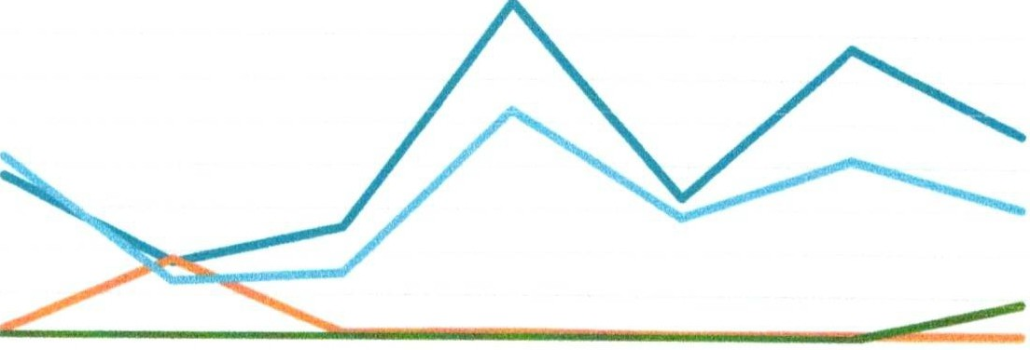

2015 2016 2017 2018
Year
2019 2020 2021

-CS024 cso 25 -cso 26 -cso 27

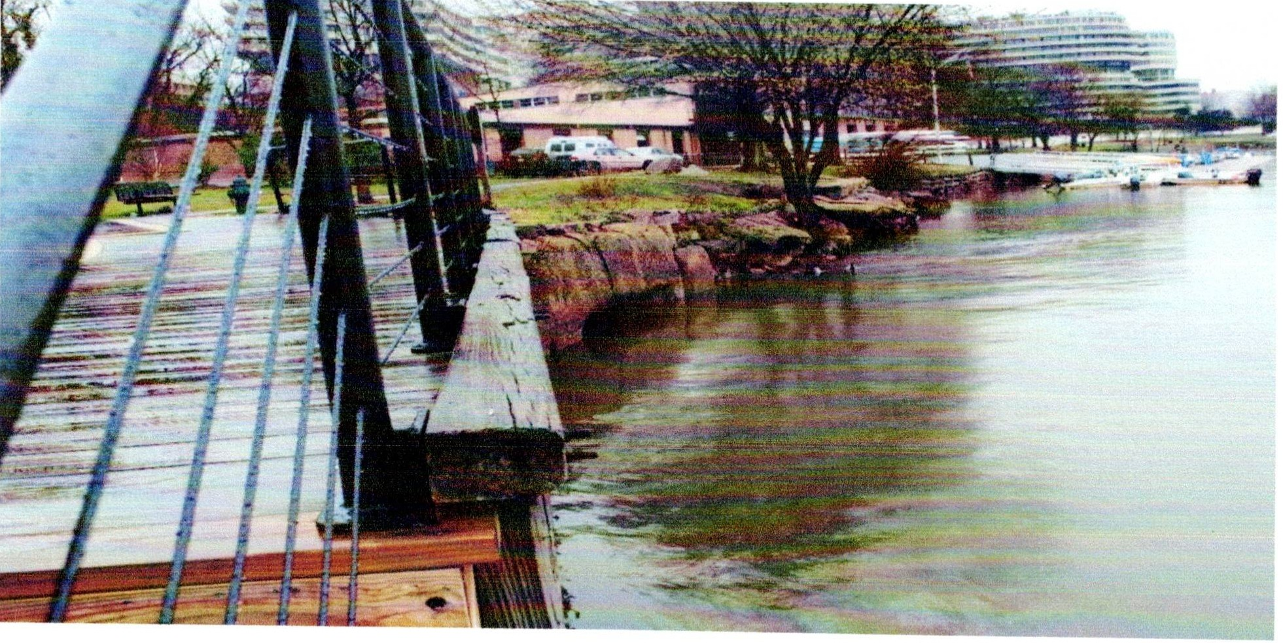
Fig 11. CSO 24 with Thompsons Boat Center in the background. {Photo by the author 2020)

The CSO of Key Bridge (CSO 28)

This CSO drainage of 21.07 acres is only a seven block section from 34th St with a section including the eastern portion of the Georgetown University campus. The outlet is 100 ft upstream of the northwest side of Key Bridge. Like CSOs 22 and 24, it is adjacent to the Key Bridge Boat House (aka Jack's). Over the seven year period it discharged over 91 mg into the Potomac.

 | 2015 | 2016 | 2017 | 2018 | 2019 | 2020 | 2021
CSO28 | 5.91 | 3.53 | 4.53 | 27.00 | 13.72 | 18.99 | 18.10

30

25
oE/J �'>O
<I)
Of)
� 15
.r=
u
rr,
6 10

5

Annual Discharge CSO 28 2015-2021 mg

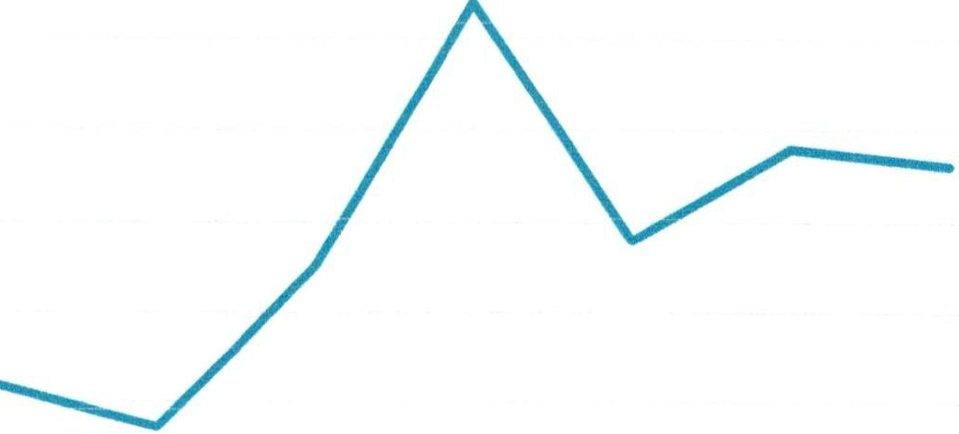
0
2015 2016 1017 2018
Year

2019 2020 2021

The Georgetown University (CSO 29)

Rather quaintly called "College Pond" in early sewer documents (was there a pond on the Campus earlier?), this immense drainage (300.79 acres) stretches from the Georgetown Campus north all the way past Burleith to Glover Park, with a sliver even touching as far north as Massachusetts Ave and Wisconsin Ave. In keeping with its drainage area, this northernmost of the Potomac CSOs discharged over 244 mg, the fifth dirtiest of the Potomac CSOs.

 | 2015 | 2016 | 2017 | 2018 | 2019 | 2020 | 2021
cso 29 | 13.57 | 12.15 | 16.24 | 80.69 | 39.49 | 60.56 | 21.74

90
80
70
OEil 60
� 50
'o-:l
-f:; 40
(/)
i:5 30
20
10
()

Annual Discharge CSO 29 2015-2021 mg

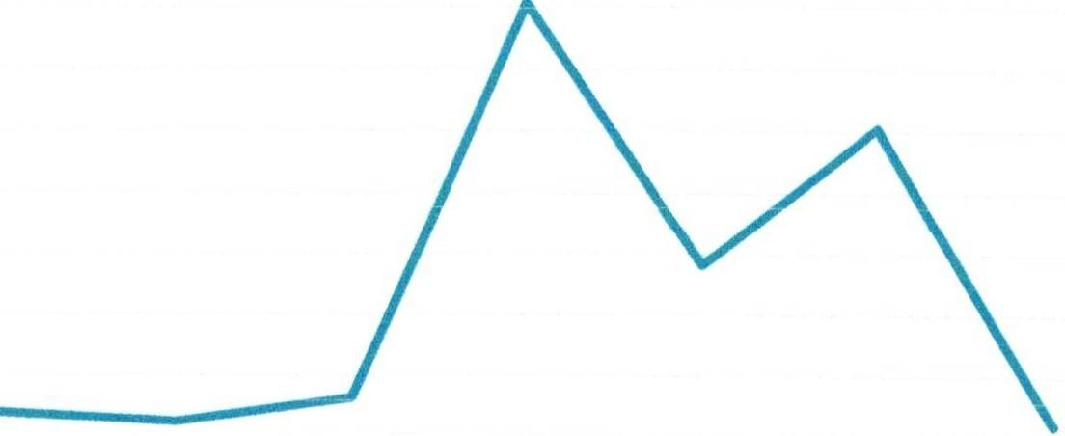

2015 2016 2017 2018
Year
2019 2020 2021

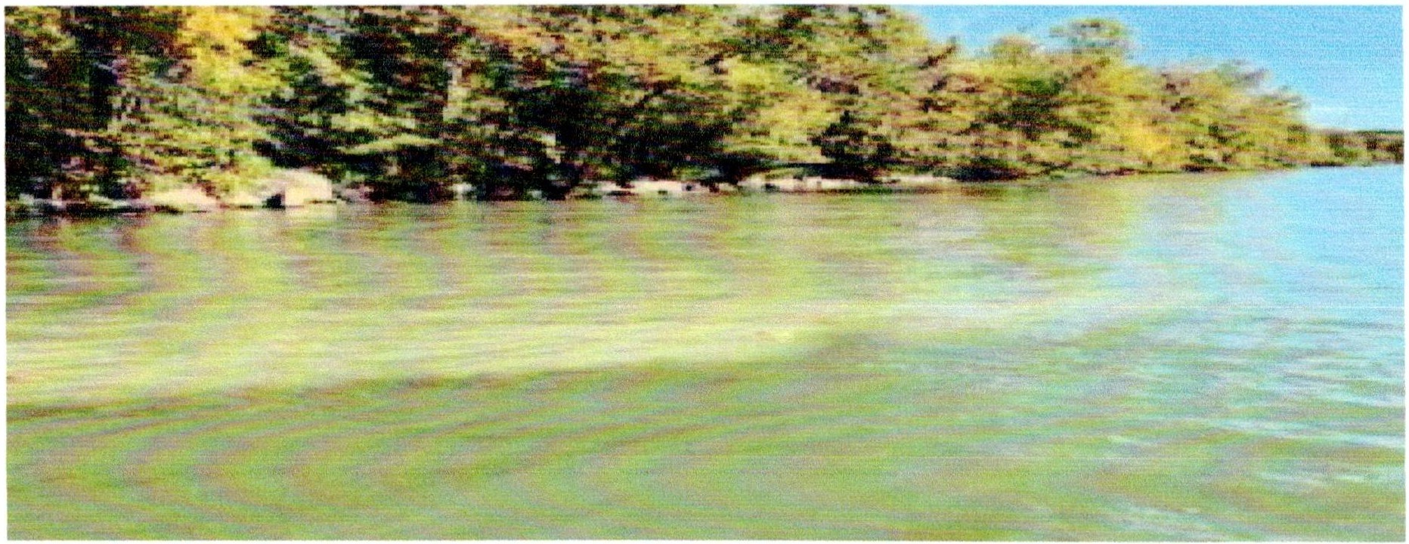
Fig.12. CSO 29 Discharge. This milky water is typical of a CSO. Located about 300 yards upstream of the Potomac Boat Club and the Key Bridge Boat Center, this CSO presents a direct threat to boaters in the area. Photo courtesy of the Potomac RiverKeeper Network.

The Potomac CSOs: What Should We Do About Them?
Although DC Water plans to complete the Potomac Tunnel by 2030, we should not wait that long to take action to curb as much of the Potomac CSO discharges as possible. In 2021 alone, Potomac CSAOs disgorged over 879 million of gallons of sewage and stormwater into the Potomac. This was a 58 percent increase in overflow volumes compared to 2015. In grappling with possible solutions, we arrived at three principles that guided our formulations:

Protect major recreational areas along the Potomac.

Institute comprehensive boater education programs to encourage swimmers and boaters to stay off the water during and a day after rainstorms when the sewers may still be running high. Boaters should observe the flashing warning lights over CSO 22 opposite the Watergate and at CSO 29,300 yards upstream of the Potomac Boat Club.DC Water should work with the NPS to install additional warning lights at CSO 24, just upstream from Thompson's Boat Center, CSO 28, just upstream from Key Bridge Boat Rental.
- Institute pilot programs in vulnerable sewersheds including CSOs 24, 28 and 29, including such measures as comprehensive water conservation measures, enhanced green infrastructure at federal facilities and expanded stormwater retention programs.
- Educate recreational users on how CSO discharges can affect their boating habits and how to take action to protect themselves. Recreational users should urge policy makers to push for additional reductions in discharges.
- Reduce the volume of water going to the overflows.
- Anticipate the effects of climate change on the CSO system that, according to climate scientists, will increase the severity and frequency of rainstorms.

There are three recreational areas that are impacted by Potomac CSOs: Thompson's Boat Center, Key Bridge Boat Rental, and the Potomac Boat Club.
Thompson's Boat Center

Thompson's Boat Center is flanked by two CSOs; CSO 24 approximately 200 feet upstream and CSO 22 about 500 feet downstream. CSO 22 is ranked third and CSO 24 ranked fourth respectively by their discharge volume over the seven year study period. Altering the four regulators could reduce flows at this location and improve water quality at and around Thompson's.
No readily apparent solution presents itself with CSO 22. Although normally, the strong currents of the Potomac dissipate the discharges, the fact is that, particularly during the doldrums of the summer months, the Potomac currents are weak and the tides will actually sweep the pollution back upstream to the Boat Center. DC Water, working with DOEE and DDOT, should consider additional mitigation measures including installation of water saving devices, rain gardens and additional stormwater control measures in the sewershed.

Key Bridge Boat Rental
Key Bridge Boat Rental is only 100 feet downstream from CSO 28. Although the CSO had a drainage area of only 21.07 acres, the second smallest of all the Potomac CSOs, it discharged over 91 mg of combined sewage over the seven year period - 4.36 mg per acre - the fourth largest based on CSO discharge per acre. Finding solutions in this seven block square sewershed is not readily apparent. DC Water, working with DOEE might institute water conservation measures, green roofs, and other stormwater control measures.

Washington Boat Club

About 300 yards upstream from the Washington Boat Club is CSO 29, whose large sewershed (300.7 acres) stretches from the Georgetown University Campus, all the way to Glover Park
Burleith. Its discharge of 244 mg makes it the fifth dirtiest of the CSO although the discharge per
acre (0.98 mg per acre) is the second smallest. Reducing this discharge per acre will not be easy. Still, work on Project A holds promise for reducing discharges at this CSO and there remain

possibilities for the installation of additional rain gardens, green roofs and other stormwater control measures in the sewershed. The first GI project in Potomac sewershed was installed in this sewershed. Rain gardens were constructed in planter strips and permeable pavement in streets and alleys were installed in two areas of Glover Park and the Burleith neighborhoods. Overall, thirty-eight permeable pavement segments and five planter bioretention facilities were constructed as part of this project which will reduce the CSO discharges at CSO 029.

Educate recreational users on how CSO discharges can affect their boating habits and how to take action to protect themselves. Recreational users should urge policy makers to push for additional reductions in discharges.
The National Park Service should undertake an aggressive campaign to educate the users of Thompson's Boat Center and Key Bridge Boat Rental about the hazards of CSOs, when they flow and how to avoid them. Similar education campaigns should be undertaken by the Washington Boat Club.

Some Solutions Are In Place; More Needs to Be Done To Protect Our Potomac
DC Water has undertaken a variety of measures in the Potomac sewersheds to reduce discharges, and some progress was made in four of the seven CSO sewersheds. For example, the sewer separation projects for CSO 25 and 26 were completed by March 23, 2023 and eliminate over 15 million gallons of overflows.
Some portion of CSO discharges at CSO 21 is fed by the East Rock Creek Diversion Sewer that originates in the Piney Branch CSO 49 in Rock Creek. GI work in Rock Creek Project B and the planned 4.2 mg holding tank will both work to reduce flows to the East Rock Creek Diversionary Sewer and ultimately to CSO 21 that gushes into the Potomac.
Making progress on stemming discharges from the remaining CSOs 20, 22, 27, and 28 will be difficult, prior to the construction of Potomac River Tunnel. Collectively these CSOs disgorged over 1,492 mg into the Potomac during the seven year study period - 26 percent of the total.
Their sewersheds range from the wide-open spaces of the Mall and museums to the more densely developed areas of Foggy Bottom, downtown and Georgetown. There may be opportunities for incremental water saving measures and raingardens. Installing extensive stormwater controls in these areas would be both disruptive and politically challenging.

Conclusion

While there has been undeniable progress in reducing flows from certain Potomac CSOs, much more needs to be done to stem these overflows before the Potomac Tunnel is in place in 2030. These measures could include more extensive use of GI, installation of warning lights at key CSOs and a robust public education for recreational users.

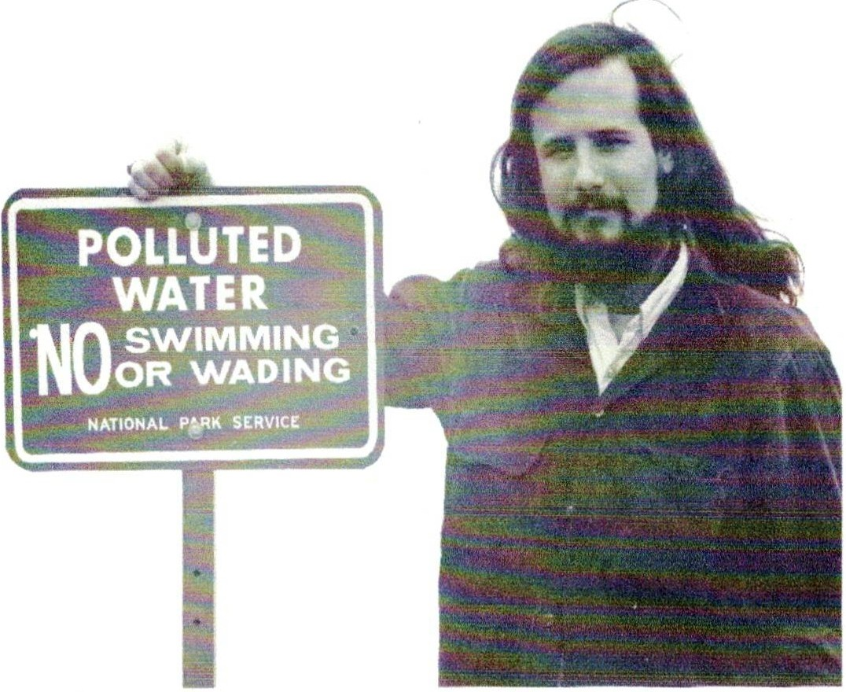

FIGURE 4. THE AUTHOR WITH A POLLUTION SIGN PLACED ALONG THE POTOMAC AND TIDAL BASIN BY THE PARK SERVICE BUT SUBSEQUENTLY REMOVED, CIRCA 1972.

References
Banta W.C. 1993. Biological Water Quality of the Surface Streams of the District of Columbia. Occasional Publications, Department of Biology, American University, Washington, DC 20016. Volume 2, no. 1.
Capital Improvement Program, Quarterly update by Paul Guttridge before the Environmental Quality and Operations Committee, February 18, 2021. Accessed from DC Water website, February 22, 2021.

"City to Block Waste Flow Into the Potomac." By William Nye Curry. Washington Post, September 19, 1971, page B-1

.DC Citizen Science Water Quality Monitoring Report, Department of Energy and Environment (DOEE), 2020. (https://www.anacostiari\crkcepcr.org/wp-contcnt/uploads/2020/11/RK-VWQM-2020-Report l·inal-with-AppencJix-A.pdl)

DC Water 2020 Budget Adopted by the Board of Directors, April 4, 2019. Accessed from DC Water.com February 18, 2021.

District of Columbia Water and Sewer Authority (WASA), 2002. Combined Sewer System Long Term Control Plan (LTCP).

"Drainage of the City" Evening Star, July 19, 1884. P. 2

Hering Report. Report upon the Sewerage of the District of Columbia. Rudolph Hering, Samuel
M. Gray, Frederic F. Stearns Board of Sanitary Engineers. House of Representatives, 51st Congress, pt session, Ex.Doc No. 445. Washington. Government Printing Office, 1890.

Metagenomic Sequencing and Quantitative Real Time PCR for Fecal Pollution Assessment in an Urban Watershed." Kyle D. Brumfield, Joseph A. Cotruvo, Orin C. Shanks, Mano Sivaganesan, Jessica Hey, Nur A. Hasan, Anwar Huq, Rita R. Colwell, and Menu B. Liddy. Waterdoi: https://doi.org/10.3389/frw2021,626849. Published February 15, 2021.

Monthly Operations Report for the Combined Sewer System. The Reports are grouped quarterly and generally available by the 28th of the month following the end of the quarter. The reports are available on DC Water's web site: DCWater.com under Publications.

Report of the Operations of the Engineers, Department of Sanitary Engineering, District of Columbia Board of Commissioners Annual Report. Various years from 1874 to 1929.

"Sewage Problem Attacked" by William Nye Curry. Washington Post, August 28, 1971
"The Sewer System Needs of City Discussed at Board of Trade Meeting. The Sanitary Aspects of the Case." The Evening Star, January 23, 1895.

Water Quality Assessment, 2009 and 2014 as submitted to US Environmental Protection Agency by the District of Columbia Department of Energy and the Environment.

Appendix

Table A. Total Annual Discharges from all the Potomac CSOs Have Been Increasing

 | 2015 | 2016 | 2017 | 2018 | 2019 | 2020 | 2021
CSOs | 555.43 | 376.57 | 629.19 | 1513.22 | 612.79 | 1283.67 | 879.67

0/)

1600
1400
1200

Annual Discharge Potomac CSOs mg

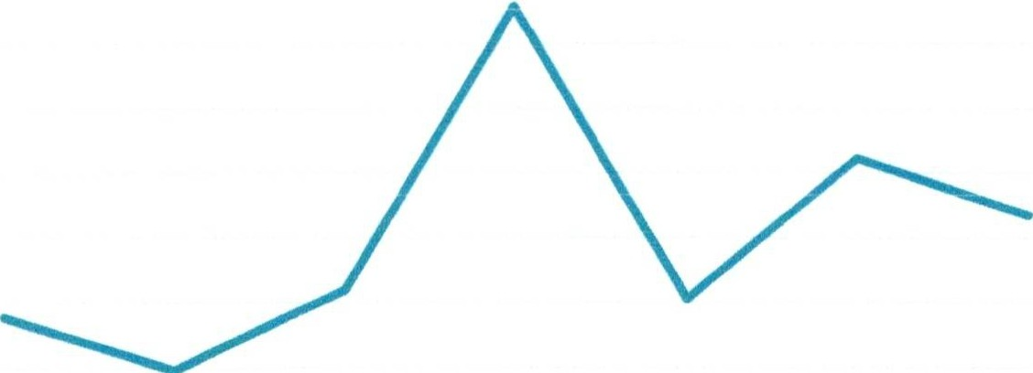
� 1000
0/)
c3- 800
.co:l
� 600
0

400
200
0

2015 2016 2017 2018
Year

2019 2020 2021

Table B. Potomac CSOs Annual Discharge by CSO 2015-2021 mg

 | 2015 | 2016 | 2017 | 2018 | 2019 | 2020 | 2021 | TOTAL
20 | 55.80 | 1.39 | 2.59 | 204.65 | 78.15 | 167.75 | 121.93 | 632.26
21 | 340.78 | 309.14 | 518.86 | 876.81 | 339.35 | 709.22 | 532.36 | 3,626.52
22 | 54.39 | 19.06 | 46.58 | 141.84 | 60.78 | 131.80 | 88.24 | 548.69
24 | 37.40 | 17.40 | 25.69 | 77.54 | 32.36 | 67.24 | 47.76 | 305.39
25 | 1.38 | 0.80 | 0.87 | 1.22 | 0.75 | 0.99 | 1.11 | 7.12
26 | 0 | 0 | 0 | 0 | 0 | 0 | 8.72 | 8.72
27 | 41.79 | 13.10 | 13.83 | 53.02 | 25.24 | 41.68 | 30.75 | 219.41
28 | 5.91 | 3.53 | 4.53 | 27.00 | 13.72 | 18.99 | 18.10 | 100.05
29 | 13.57 | 12.15 | 16.24 | 80.69 | 39.49 | 60.56 | 21.74 | 244.44

Table C: Potomac CSOs Ranked by Discharge Volume 2015-2021 mgd

cso 21 | 3,626.51
CSO20 | 632.26
CSO22 | 548.69
CSO24 | 305.39
CSO29 | 244.44
CSO27 | 219.41
CSO03 | 166.21
CSO28 | 91.78
CSO25 | 7.12
CSO26 | 8.72

