The Combined Sewer Overflows of the Anacostia River
Where They Are; When They Flow
and
What We Should Do About Them

Marchant Wentworth
Wentworth Green Strategies
May, 2022

Marchant Wentworth
Wentworth Green Strategies
903 Hamlin St NE
Washington, DC 20017
202-526-3389
Marchant_wentworth@msn.com_
Website: Wentworthgreenstrategies.com

Foreword
This report is the third of a series of papers that strive to explain why our rivers and streams are polluted and what we can do about it. The first paper, released in March, 2021, described the leaking sewers of Rock Creek. A second paper, released in September, 2021 identified the combined sewer overflows in Rock Creek and described where and when they overflow. This report, like the previous efforts, is not designed to be a scientific study but to merely gather information from existing data sets and present it in a way easily understood by the layperson. In this paper, we examine the combined sewer overflows (CSOs) on the Anacostia River—the volume and the frequency of their overflows—and what might be some of the solutions to begin to stem the pollution.
To characterize the CSOs on the Anacostia, I made extensive use of the Quarterly Operations Report for the District of Columbia, prepared by the DC Water and Sewer Authority (DC Water), Department of Sewer Services. This report, available on the DC Water website by 23rd of the month following the end of the quarter, not only contains details on such things as the volumes of wastewater pumped, trash removal, and daily rain data, but, for the purposes of this paper, it also contains the results of a computer model of the discharges of each of the combined sewer outfalls for each calendar quarter from the District’s CSO system. It was these data that I relied on for this paper. Because the DC Water computer-generated data is a model, the discharge data and the accompanying graphs in this report may or may not resemble actual conditions. But the model has been verified with real time measurements and viewed over the five-year study period, I am confident they supply a reasonably accurate picture of the functioning of the CSO system.
Moreover, after the Anacostia Tunnel went in service on March 20, 2018, all the CSOs on the Anacostia are metered except CSO 005, 013 and 014. The meters are permanent and were installed as part of the Tunnel construction. They supply the detailed overflow volumes of the system that were heretofore not available. Before Mar 20, 2018, overflow volumes were based on models that were calibrated based on meter data collected during monitoring periods.

Congress was always reluctant to appropriate the needed funds and DC mayors habitually tried to siphon off cash from the revenue-based sewer and water fund that was supposed to furnish the money to maintain the sewer system. As a result of this arrangement, the Sewer and Water Fund was grossly underfunded and the system suffered. Despite generous grants under the New Deal in the 1930s that funded various trunk sewers and the all important treatment plant, what was desperately needed was a reliable funding source. That didn’t arrive till 1996 with the federal legislation that created the independent DC Water and Sewer Authority, now known as DC Water. This gave the Authority, for the first time, the ability to issue bonds that could supply the funding to modernize the system. It also could protect the agency from the periodic raids on the Sewer and Water Fund by politicians. Another pleasant result is that the consistent triple A bond rating has placed DC Water on firm financial footing and reduced borrowing costs for ratepayers.
But it took a citizen suit filed in October, 1999 from the Anacostia Watershed Society, the DC Chapter of the Sierra Club, The Canoe Cruisers Association, and a band of other clean water advocates, ably guided by the legal wizards at Earthjustice to force action to clean up the combined sewer overflows that have plagued our waterways for over a century. Later joined by EPA and the Justice Department, the consent decree signed in March, 2005 to settle the lawsuit mandated, among other things, the creation of the Long Term Control Plan (LTCP) to curtail the worse of the combined sewer overflows through, along with other initiatives, the use of massive 23 foot concrete tunnels that store the combined stormwater and sewage until after the rains and pump it to the treatment plant. In the Piney Branch CSO#19 sewer shed, a holding tank will be paired with a set of “green infrastructure” projects to slow, and capture where possible, the huge volume of flows of stormwater generated in the massive sewershed.
As of March 2018, the first leg of the Anacostia tunnel from Blue Plains to CSO19 near the RFK stadium is already working to remove not only 96 percent of the overflows but, as a side benefit, it traps tons and tons of trash from entering the Anacostia. Construction of the final leg of the Anacostia tunnel, the Northeast Boundary portion, has been completed and could accept overflows in 2023. Plans for a similar tunnel for the Potomac are finalized and construction is set to commence in spring, 2023 and will be completed by March, 2030.
All of the Anacostia’s CSOs were diverted to the tunnel on March 20, 2018.

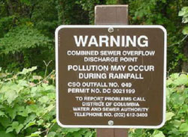
Figure 1. Under the terms of the Consent Decree, each CSO outfall is required to have a small brown and white sign identifying the outfall by number and explaining what it is and warning of polluted water. As the vast majority of the CSO structures are on land controlled by the National Park Service, any identifying sign, even one required by the federally-mandated Long Term Control Plan, must conform with the Park Service signage protocols.

Acknowledgements

Deep thanks for the staff of DC Water for their diligence in furnishing the data that has supported this report. As with the previous report, I am indebted to Carlton Ray, retired Director, Clean Rivers Project, as well as Dr. Moussa Wone, Director, Clean Rivers Project and his staff including Mr. Salil M. Kharkar and Mr. John Cassidy for their generosity in supplying needed corrections to the computations and background on some of the Anacostia CSOs. My appreciation continues to flow to Mr. Emanuel Briggs, Manager, Community Outreach, Office of Marketing and Communication, DC Water who has been unfailingly responsive to my queries. My colleagues in the environmental community, particularly Mr. Chris Wiess, Executive Director, DC Environmental Network, all continue to furnish needed support and sage political advice. Trey Sherard, of the Anacostia Riverkeeper, Philip Musegass and Dean Naujoks of the Potomac Riverkeeper, and Jim Foster, formerly the Executive Director of the seminal Anacostia Watershed Society have all offered valuable insight.
Family and friends continue to offer encouragement to this somewhat odd quest to grapple with pollution in Rock Creek. But, as always, it continues to be the support of my partner Marion Granigan, whose ongoing faith in me continues to amaze and humble me. She continues to deserve a parade, Marmite on demand, and endless time to quilt.
My apologies to any folk I may have missed. My debt to all of you is immeasureable.
Of course, responsibility of mistakes, errors, and omissions are mine alone.

Abbreviations
BPWWTP – Blue Plains Wastewater Treatment Plant
CD – Consent Decree
CSO – Combined Sewer Overflow
DOEE – District Department of Energy and the Environment
EPA – US Environmental Protection Agency
GI – Green Infrastructure
LID – Low Impact Development
LTCP -Long Term Control Plan
MG – million gallons
MGD – million gallons a day
NEB – Northeast Boundary Sewer
NPS – National Park Service

Executive Summary

- The total discharges of the fourteen Anacostia CSOs have dramatically decreased over the six years of the study period. In 2015, the combined Anacostia CSOs discharged over 1,444 million gallons (mg) of overflow to the River. In 2021, those discharges were cut to 75.66 mg – a 95 percent reduction. (See Table A).
- Of the fourteen Anacostia CSOs, the Northeast Boundary CSO #19 alone contributed almost half the overflows discharged to the Anacostia over the six-year study period 2015-2021 and over twice the volume of overflow of the next dirtiest CSO #10 at the Main Pumping Station. (See Table B).
- Ranked by neighborhoods (see Table B), the dirtiest CSO on the Anacostia is CSO #19, followed by the five CSOs at the Main Pumping Station. The East Bank CSOs are the least polluting with the CSO #5 flows cut from 19.38 mg in 2015 to zero 2021. Similarly, flows from its upstream neighbor, CSO #7, were curtailed from a high of 25.3 mg in 2015 to a low of 0.72 mg in 2021.

Recommendations

- Reduce overflows by CSOs #10 and #12 by working with the General Services Administration (GSA) and other landowners in the sewershed to reduce flows to the combined sewers. Institute pilot programs such as comprehensive water conservation measures, enhanced green infrastructure at federal facilities and expanded stormwater retention programs.
- Stay off the water during and a day after rainstorms when the sewers may still be running high.
- Avoid the area around the Main Pumping Station and the area around the Northeast Boundary Sewer - CSO #19 just downstream from RFK stadium - all the time. Take special care to observe the flashing warning lights over the outfalls of the Main Pumping Station.
- Despite the reduction in CSOs to the River, be aware that stormwater outfalls are largely uncontrolled and still spew polluted water and trash into the Anacostia.
- Anticipate the effects of climate change on the CSO system that, according to climate scientists, will increase the severity and frequency of rainstorms with concomitant increases in CSOs.

Race and Sewage in Washington

No discussion about sewage in the District is complete without at least a mention of race. The effects of racist policies have directly resulted in the vast differences in treatment and outcomes for the Potomac and the Anacostia. The Potomac got a floating barge featuring symphonies and musicals. The Anacostia got the huge outfall from the NE Boundary Sewer that spewed millions of gallons of raw sewage daily into the river. The Potomac got the Kennedy Center for the Arts and Thompson’s Boat Center for rowers. The Anacostia got farms of fuel tanks and sand and gravel operations. The Potomac got flotillas of power boats docked in Georgetown during the summer. The Anacostia got struggling black-owned marinas surrounded by pollution from sewer overflows and in perpetual danger of being silted out of existence. The Anacostia did get Langston Golf Course and the Kenilworth Aquatic Gardens. But even these were tarnished by the Kenilworth Dump that was only shut down in the 1950s after a nine year boy, searching for bicycle parts, was burned to death when the ever simmering fires of the dump turned on him.
These racial disparities are just starting to be addressed after a more than a century of enforced White ignorance. Change on multiple levels is coming to the Anacostia that must be benefiting from all the money and attention being heaped on it.
Literally dozens of organizations ranging from the stalwart Anacostia Watershed Society and the Anacostia Riverkeeper to the Anacostia Waterfront Trust, DOEEs Anacostia River Sediment Project, the Anacostia Watershed Restoration Partnership, and a laundry list of groups both within and outside the government are all actively working to reverse the decline of the Anacostia. It took more than a century to despoil the Anacostia. Restoring it will take time. My deep appreciation goes out to all the staff and volunteers that work on the Anacostia for their dedication and persistence.
On a final note, I am more than aware that my previous studies have centered on streams in White Washington. This study of the CSOs of the Anacostia is one step to rectify that inequity. In addition, work to rehabilitate streams in the Anacostia watershed in the Black neighborhoods surrounding Pope’s Creek, Watts Branch, Stickfoot, Hickey Run and others are either planned or on-going. Hopefully these projects are the first steps towards equity and environmental justice that are so urgently needed.

The Combined Sewer – An Artifact of Sanitary Engineering

The combined sewer is an antiquated sanitary engineering artifact that attempted to solve the perpetual problem in sanitary engineering: how to accommodate the huge volumes of stormwater and wastewater as quickly and cheaply as possible and with minimal disruption to the neighborhood. This system combined wastewater from toilets and baths in the same pipe with stormwater from roofs and streets by confining the wastewater to a central sunken channel in a middle of the larger pipe. (See Figure 2). During dry weather, as long as the sewage was contained in the channel, the wastewater flowed, usually by gravity, to our treatment plant. But during rainstorms, the pipes fill quickly and the sewage laden wastewater overtops its channel and flows into the nearest water course.
When It Rains – It Pours – A Preview of the Rains to Come?
On an otherwise unremarkable day on July 8, 2019, the US Women’s Soccer Team won its 4th World Cup, Iran raised uranium enrichment levels, and it rained. At one point, meteorologists estimated it was raining 5 inches an hour. When it was over, the storm had dumped 3.44 inches on Washington National Airport – a one day record. Three billion gallons of water fell from the sky. For those having trouble imagining that, it was the equivalent of 27 million hot tubs or 48,000 Metro rail cars. Avenues became creeks; Metro entrances, cascading waterfalls. When it hit our sewer system, the effect was dramatic. Fountains of sewage shot from manhole covers at 17th and D Sts NW and F St and Virginia Ave NW. CSO 12 near the baseball stadium gushed for almost three hours. CSO #21 by the Kennedy Center overflowed for about an hour and a half. And CSO #34 near P Street Beach, conveying the remnants of the old Slash Run Creek that used to flow through downtown, discharged its load into Rock Creek for almost half an hour. Clearly, this was no time to be in the water.
This extreme example shows us the worst that could happen. But climate scientists tell us this event is merely a preview of the future effects of climate change. Even now, a gentle summer rain produces a torrent of billions of gallons of storm water and combined sewer overflows in our often out of sight, out of mind sewer system.
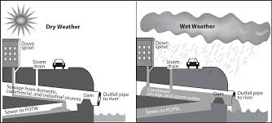
Figure 1. This schematic illustrates generally how CSOs work to pollute nearby waterways
When this system was first employed in DC in the heyday of sewer construction during “Boss” Shepard’s tenure as Mayor in the 1870s, sensibilities around pollution were quite a bit different than today. Then the adage “the solution to pollution is dilution” was in full sway. Engineers computed that the offensive overflows would only occur when there was as much as three times the amount of stormwater as wastewater, theoretically making pollution impact on the stream, in their eyes, relatively minor.

Why Can’t We Just Separate Our Sewers?

To separate combined sewers, crews dig trenches seven to ten feet deep, usually in the middle of the street, locate the offending pipes, and reconnect them to pipes leading to the treatment plant. This is a messy, expensive, and cumbersome process that is understandably not popular with the adjoining neighbors. It is best accomplished when the number of sewers that need reconnecting is relatively small or when utility work is already scheduled for the location and the neighborhood disruption is already happening anyway. But even then it is hardly a happy time for the locals. On Georgetown’s M Street, for example, during work to realign and improve the 100 year old gas, electric and sewer lines in 2001 deadline after deadline slipped as crews ran into surprises digging into the century old infrastructure. Trendy shop owners howled about losing customers and irate (and often influential) Georgetown residents hammered on politicians to force the utilities to hurry up and get the job done. DC Water is understandably reluctant to undertake a similar sewer separation projects. Small wonder that they were eager to embrace a deep tunnel system a 100 ft. beneath the surface that would store the polluted rainwater and would be much less disruptive.

However, as it developed, there were a number of problems with this approach. For one thing, under pressure from real estate speculators, rapid development occurred in the District, particularly after the First and Second World Wars that brought armies of office workers to town. This flood of folks overloaded the sewer system built to accommodate a much smaller population and overwhelmed the treatment plant that was habitually forced to discharge its load with minimal treatment back to the Potomac River. This had devastating results. Fish died. The Potomac stank. Huge floating algal mats formed as far upstream as Georgetown, making pleasure boating hardly a pleasure. Instead of opening just during rain storms, some of the overflows, connected to pipes far beyond their capacity, flowed constantly. Adding to the problem, the District’s Department of Sanitary Engineering, due to lack of appropriations from Congress and politicians siphoning off money from the Sewer and Water Fund, was perpetually behind in badly needed maintenance of the system. And the Potomac, Anacostia and Rock Creek paid a heavy pollution price. In 1972, the DC Council banned any contact with all of them.
But even much earlier in the late 1800’s, it did not take an expert to know that District’s sewage was flowing into the Washington Canal and festering there subject only to the tides. In response to the ongoing pollution and the stench and malaria and cholera that accompanied it, President Harrison convened a special panel to review the situation and recommend improvements. The "Hering Report" released in 1907 contained all the key elements for creating the present day sewer system. For example, the city started building separate systems of wastewater and stormwater. Generally speaking, this meant that newer portions of the District, particularly the White middle class parts, received separate sewers, while the older (and Blacker) portions of the city, generally the city south of Florida Ave and stretching east past Capitol Hill to the Anacostia River, remained on the combined system. Some exceptions include most of Southwest, that got its sewers separated as a consolation prize for the devastation caused by the “urban renewal” that wiped out complete neighborhoods, and most of the Anacostia neighborhood east of the river. With the exception of Georgetown, almost all the land west of Rock Creek Park is served by separate sewers.
Other ideas contained in the Hering Report included the construction of large interceptor sewers to intercept or block sewage from flowing into Rock Creek, Potomac and the Anacostia and the all-important siting of a treatment plant downstream from the city. All that remained was to gain the funding to implement the program. That effort would take over a century.
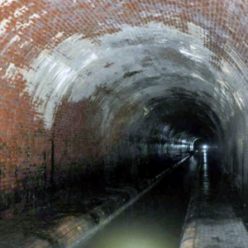
Figure 2 Inside The Tiber Creek Sewer, January 2017. This trunk sewer contains the remnants of the once mighty Tiber Creek, one of the largest creeks in the city. It originated in springs near the soldiers home, FLOWED south roughly along north capitol street and then one branch turned west to provide most of the flow of the ill-fated Washington canal, now Constitution Ave. A second branch flowed south, under what is now The Rayburn House Office Building to connect with Jones Creek and the Anacostia. (see Figure 3) it is now a typical combined sewer showing a central channel or cunette set in concrete to convey the sanitary waste overarched by multiple courses of brick. During heavy rains, this entire tunnel might fill.

CSO Regulator Structures
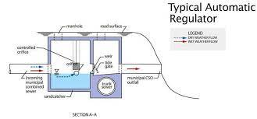
In order to relieve the pressure from the volumes of combine wastewater stormwater and protect the capacity of the sewer system, CSOs have special valves that open during heavy rains (and sometimes not so heavy rains) to disgorge the contents of the pipe, now mixed sewage and rainwater, into the nearest waterway. This protects the sewer system but grossly pollutes the nearest creek or stream. The flows out of these pipes are controlled by CSO regulator structures.
Figure 2 This regulator has a float that OPENS A valve when the flow OF COMBINED sewers reaches a certain level.
The Monthly Operations Report records 24 CSO regulator structures for the Anacostia CSOs. (See the list in .Table D.) These structures vary widely as to design, operation and location. For example, some structures are merely simple weirs or dams across the pipes directing water behind the weir to the treatment plant. In the event of heavy rains, the combined wastewater overwhelms the weir and flows into a pipe leading to the CSO outfall. Some structures, like the one pictured in Figure 2, feature automatic gates to control the overflows. Some of the structures are just up the pipe from their associated outfall but others are blocks away and work to function multiple outfalls. Each CSO sewershed has its unique typography and hydraulics and each overflow itself is governed by a CSO regulator that determines when and how often combined wastewater is released to the creek.

When It Rains, It Overflows

Regulators can help stem the overflows but it is rainfall --both its intensity and volume – that has the most effect on the frequency and duration of combined sewer overflows. But rainstorms in the District vary year to year and are unlikely to be uniform across the city. Looking at the rainfall data (see Table 1) for National Airport during the study period, we note that 2018 was the wettest year, followed by 2020.
Table 1. Annual Rainfall National Airport (inches)
2015 | 45.02
2016 | 31.7
2017 | 35.6
2018 | 66.28
2019 | 42.34
2020 | 57.34
2021 | 44.09

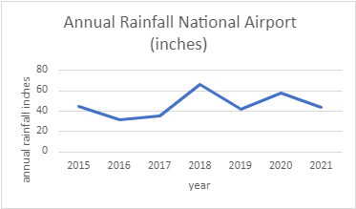

Interestingly, rain did not fall equally on all sections of the city. For example, in September, on average the wettest month of the wettest year – 2018 -- it rained 2.59 in. at Brentwood, but the same storm dumped 9.73 in. at Main Pumping and 10.16 in at Rock Creek. Conversely, in May it rained 8.01 in. at Brentwood but 7 percent less across town at National Airport.

Table 2: Rainfall At Five Different Measuring Stations -- 2018 (inches)
 | Brentwood | Bryant | Main Pump | Rock Creek | Natl Airport | Avg
Jan | 0.64 | 0.61 | 0.7 | 0.74 | 0.94 | 0.726
Feb | 4.85 | 4.62 | 4.44 | 4.63 | 4.79 | 4.666
Mar | 1.97 | 1.88 | 1.98 | 1.93 | 1.92 | 1.936
April | 3.44 | 3.67 | 3.28 | 3.94 | 3.59 | 3.584
May | 8.01 | 7.98 | 7.8 | 8.79 | 7.41 | 7.998
June | 4.05 | 4.45 | 4.04 | 4.13 | 5.21 | 4.376
July | 8.53 | 9.09 | 7.46 | 7.65 | 9.73 | 8.492
Aug | 4.45 | 4.57 | 4.63 | 4.4 | 4.85 | 4.58
Sept | 2.59 | 10.68 | 9.57 | 10.16 | 9.73 | 8.546
Oct | 2.16 | 2.99 | 2.9 | 2.7 | 0[1] | 2.6875
Nov | 6.78 | 7.23 | 7.35 | 7.41 | 0 | 7.1925
Dec | 5.96 | 5.64 | 5.36 | 5.39 | 0 | 5.5875
[1]There appears to have been a malfunction at the Natl Airport site for the months of Oct, Nov, and Dec.
Notes: Brentwood is the Brentwood Reservoir at Mt. Olivet Rd and 9th St NE, Bryant is the Bryant St Pumping Station at McMillan Reservoir adjacent to Howard University, Main Pump is the Main Pumping Station at the base of New Jersey Ave SE. on the west bank of the Anacostia, Rock Creek is the Rock Creek Pumping Station at 30th and K Sts NW and National Airport is on west bank of the Potomac River, west of Hains Point.
To arrive at a reasonable representation of rainfall in the District, DC Water has chosen to use the rainfall at Washington National. The average levels of all five stations are within the range of values at National Airport and the use of the somewhat higher National Airport numbers may provide a small margin of safety and perhaps one way to factor in the inevitable effects of climate change that scientists tell us will increase both rainfall frequency and duration.

The Anacostia Combined Sewer Overflows: Where They Are; When They Flow

The Long Term Control Plan (LTCP) lists fourteen combined sewer overflow outfalls on the Anacostia. This compares to fourteen on the much swifter flowing Potomac and an astounding twenty-nine on the much smaller Rock Creek.
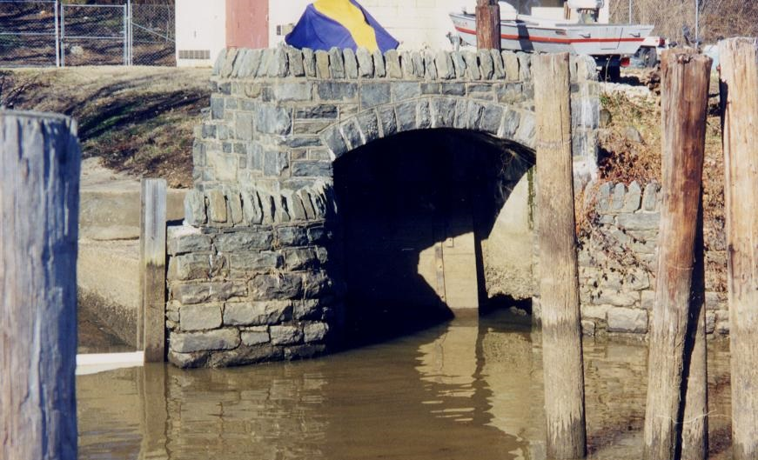
Figure 3: This fortress-like structure is typical of many of the CSO outfalls along the Anacostia. Under the terms of the Consent Decree, They are inspected at least once a month to ensure the tide gates are working properly to prevent water from entering the sewer system.

Sewer Drainage Areas

No examination of the Anacostia CSOs is complete without looking at where the runoff and sewage comes from. For that, we can turn to computerized maps of sewer drainage areas created by DC Water. Below, we see a DC Water interactive map (Figure 4) detailing the location of each outfall and drainage areas for each outfall. (See also Table C, which details each CSO and its drainage acreage.)
Notable on the Anacostia side, is the immense acreage of CSO #19 – the largest in the system --, depicted in green. Not insignificant are the drainage acreages of CSO #10 (B St/NJ Ave) and CSO #12 (Tiber Creek) – areas in yellow and blue respectively – that encompass much of the area of downtown Washington. The detailed descriptions of the various drainage areas by neighborhood are provided below.

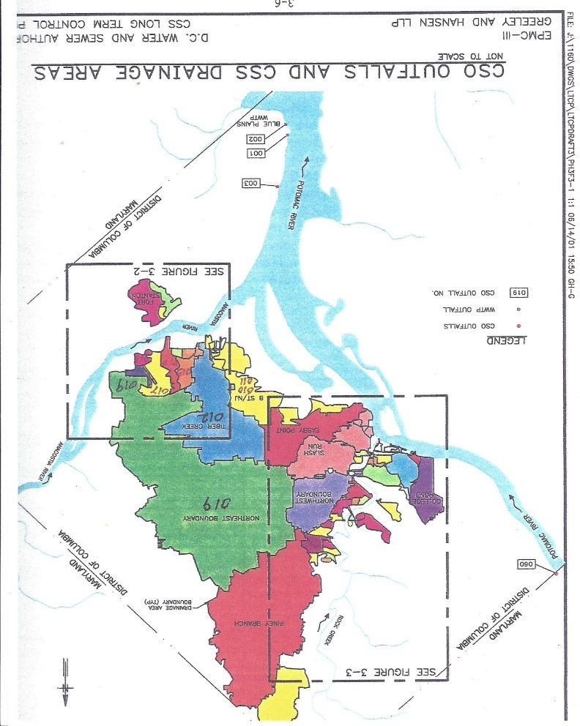
Figure 3. This computerized map shows the acreage of the various CSOs in the system

https://www.arcgis.com/apps/webappviewer/index.html?id=7796821c5b6a4166b4eae7f17d915a78&extent=-8601958.9805,4694391.6523,-8546924.3202,4724737.1525,102100.

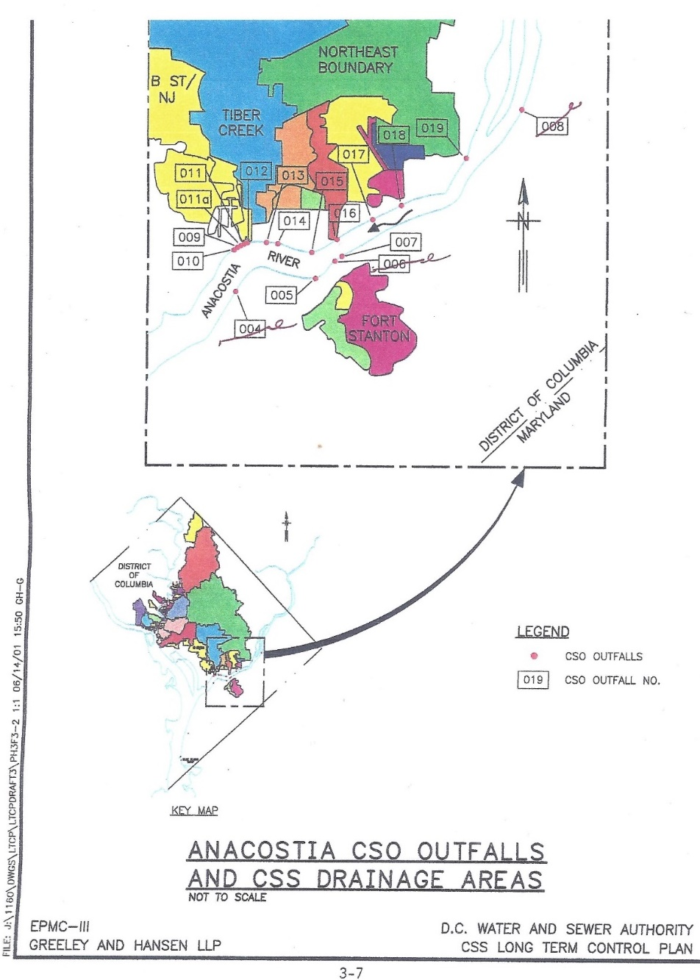
Figure 4 The detail acreage of the Anacostia CSOs

Where the Combined Sewers Are and When They Flow
This study divides the fourteen Anacostia CSOs into five neighborhoods based on the sewershed served by that particular outfall. (See Appendix, Table D.) Each neighborhood is then ranked according to the amount of CSO discharge from that particular area (Table B). This gives boaters, fishers, and other users of the River the ability to know where the polluting CSOs are and when to avoid them.

Overflows by Neighborhood
We discuss each of the neighborhoods with a graph showing the discharges of their associated CSOs over the 2015-2021 study period. (See also Table C in the Appendix which details the overflows by outfall for the period of 2015-2020.) In general, the overflows were most active during the unusually wet year of 2017. The neighborhoods are grouped starting from the most downstream overflows in East Bank of the Anacostia and Main Pumping Station on the West Bank and proceeding upstream to the Navy Yard, then the CSOs of Capitol East/Barney Circle, and finally the huge Northeast Boundary Sewer (Figure 8) that we will discuss in detail later in a separate section.

East Bank Anacostia CSOs (CSOs #5 and #7)2015-2021
This group of two CSOs is comprised of CSO #5 on the east bank of the Anacostia, across the river from the Navy Yard and CSO #7 upstream from it underneath the 11th St Bridge. Both CSOs have comparative little discharge over the five year study period. Cooperating with the District Department of Transportation as part of the 11st Bridge Project, DC Water constructed a diversion chamber adjacent to the southbound lanes of I-295 and bored a tunnel to intersect with the Anacostia tunnel. Overflows from both CSO #5 and #7 were then diverted away from the Anacostia to the Anacostia Tunnel in March, 2018. As a result, overflows to the Anacostia from CSO #5 have been reduced from 19.38 mg to 0 in 2021 and flows from CSO #7 were cut from 25.33 mg in 2015 to 0.72 mg in 2021. (See Table below).
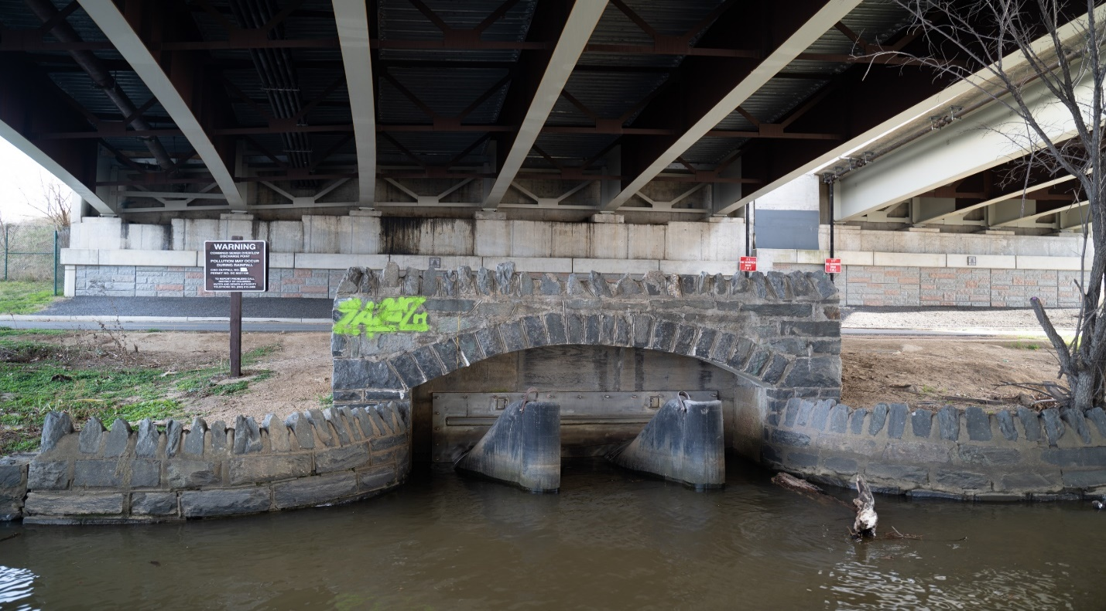
Figure 5 CSO #7, pictured here underneath the 11th St Bridge on the East Bank of the Anacostia, formerly received flows from the Ft. Stanton Area of Anacostia but in March, 2018 those flows, along with flows from CSO #5 were diverted to the Anacostia River Tunnel.

CSO #5 has a small drainage area of only 66 acres along Shannon Pl SE and Martin Luther King Ave north to Good Hope Road and south to Morris Road to Erie St SE. the drainage area of CSO #7 188 acres – twice the size of CSO #5 and is centered roughly around the Cedar Hill area of the Frederick Douglass National Historic Site. It extends east to U St SE, west to Maple View Pl.SE and south to the northern section of Fort Stanton Park.

Annual Discharge East Bank CSOs 2015-2021 (mg)
 | 2015 | 2016 | 2017 | 2018 | 2019 | 2020 | 2021 | Total
CSO 5 | 19.38 | 9.23 | 14.36 | 1.89 | 0 | 0 | 0 | 44.86
CSO 7 | 25.33 | 8.09 | 18.58 | 10.11 | 3.85 | 1.65 | 0.72 | 68.33
Total | 44.71 | 17.32 | 32.94 | 12 | 3.85 | 1.65 | 0.72 | 113.19

The CSOs of the Main Pumping Station (CSOs #9, #10, #11, #11a and #12)
2015-2021

As you can see from the neighborhood rankings in Table E, the CSOs in the area of the Main Pumping Station are the second dirtiest on the River and should be avoided—particularly during and after rainstorms. Over the study period, these CSOs dumped almost 800 mg of combined sewer overflow into the Anacostia.
The sewersheds for these CSOs are among the most extensive in the system, stretching from the Main Pumping Station northwest well past the Mall and including the Federal Triangle. CSO #9 is the smallest in drainage area of only 41 acres. It collects the stormwater and sewage from an area extending from O St to the south, to M St SE to the north, 1st St SE to the west and Canal St to the east. CSO #10 (including CSO #11 and #11a) with a drainage of 733 acres is a huge patchwork that extends from M St SW to the Southwest Freeway, with another part continuing to the northwest and extending all the way past the National Mall, the Federal Triangle and as far north as F St NW. Then the drainage territory extends east to the I-395 tunnel and west to 14th St NW. CSO #12 with a drainage area of 1,154 acres is the remnant of the lower section of Tiber Creek. It extends north from the Main Pumping Station, past the Southwest Freeway and includes a huge swath of land from the Rayburn House Building to 5th St SE on Capitol Hill and extending north to New York Ave , west to 7th St and east out Maryland Ave as far as 12 St NE.
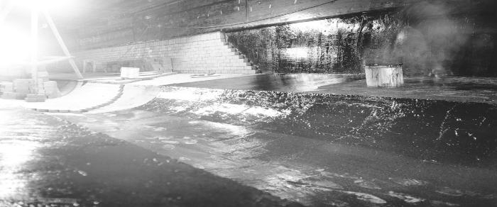
Figure 6 A Sewer Runs Through It. The sub-subbasement of the Rayburn House Office Building showing the channel for the Tiber Creek sewer during construction in the 1960s.
The Annual Discharge CSOs of the Main Pumping Station (CSOs #9, #10, #11 and #12) - 2015-2020 (mg)

CSO | 2015 | 2016 | 2017 | 2018 | 2019 | 2020 | 2021 | Total
CSO 9 | 11.58 | 4.93 | 8.05 | 1.89 | 0.49 | 0.31 | 3.94 | 31.19
CSO 10 | 156.52 | 71.91 | 127.43 | 106.07 | 47.46 | 34.37 | 10.28 | 554.04
CSO 11 | 5 | 3.33 | 3.33 | 0 | 0 | 0 | 0 | 11.66
CSO 11a | 0 | 0 | 0 | 3.86 | 1.64 | 0 | 0 | 5.5
CSO 12 | 70.64 | 2.86 | 39.72 | 51.25 | 27.91 | 14 | 0.69 | 207.07
Total | 243.74 | 83.03 | 178.53 | 163.07 | 77.5 | 48.68 | 14.91 | 809.46

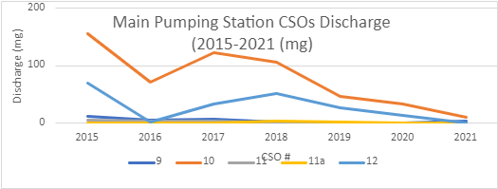

The CSOs of the Navy Yard (CSOs #13, #14, and #15) 2015-2021

The CSO 13, the remnants of the Canal St. sewer, is only 20 acres comprising a narrow block of land from 4th St SE and north to Eye St SE. CSO 14 drains 128 acres in near Southwest just south of the SW Freeway, north to North Carolina Ave SE, east to 8th St SE and west to 6th St. SE. CSO #15 is smaller at 30 acres and includes most of the Navy Yard from the Anacostia River north to the Southwest Freeway, west to Paulding St and east to 11 St. SE.

Annual Discharge CSOs of the Navy Yard (CSOs #13, #14 and #15)
2015-2021 (mg)
 | 2015 | 2016 | 2017 | 2018 | 2019 | 2020 | 2021 | Total
CSO 13 | 10.1 | 6.28 | 7.51 | 3.13 | 0.4 | 1.1 | 0 | 28.52
CSO 14 | 27.84 | 10.03 | 22.66 | 7 | 0.84 | 2.92 | 0 | 71.29
CSO 15 | 7.77 | 2.23 | 3.85 | 0.05 | 0 | 0 | 0 | 13.9
Total | 45.71 | 18.54 | 34.02 | 10.18 | 1.24 | 4.02 | 0 | 113.71

The CSOs of Capitol East/Barney Circle (CSOs #16, #17 and #18) 2015-2021 (mg)

CSOs #16, #17 and #18 are situated between the 11th St Bridge and CSO #19 near RFK Stadium. They are proximate to a series of Marinas and the Anacostia Community Boat House. Until their overflows were diverted into the Anacostia Tunnel in March 2018, the boaters in this area were long plagued with their pollution. CSO #16 drains an area of only 153 acres – a narrow corridor that extends north from the Southwest Freeway Bridge (I-695) to North Carolina Ave SE, west to 6th St SE and east to 11th St SE. But CSO #17’s drainage area is almost 260 acres and extends from Southwest Blvd north to East Capitol St., curving east to 16th St SE and south along Massachusetts Ave to the Congressional Cemetery. CSO #18 has a drainage area of almost 49 acres in two sections. The first centers around Barney Circle and Pennsylvania Ave. SE. The second parcel is only a couple of blocks square from Independence Ave SE, south to D St SE, west to 13th St. SE east to 15 St. SE.

Annual Discharges Capitol East/Barney Circle (CSOs #16, #17 and #18)
2015-2021 (mg)
 | 2015 | 2016 | 2017 | 2018 | 2019 | 2020 | 2021 | Total
CSO16 | 21.32 | 6.51 | 13.59 | 0.55 | 0 | 0 | 0 | 41.97
CSO 17 | 45.91 | 21.44 | 37.03 | 3.56 | 0 | 0 | 0 | 107.94
CSO 18 | 30.51 | 12.47 | 22.52 | 1.61 | 0 | 0 | 0 | 67.11
Total | 97.74 | 40.42 | 73.14 | 5.72 | 0 | 0 | 0 | 217.02

The Sad Saga of the Northeast Boundary Sewer
Trained as a surveyor, not as an engineer, the Southern landowner George Washington could hardly be blamed for not having the nuances of stormwater management uppermost in his mind when he urged Hamilton and Madison to site the Capital at the confluence of the Anacostia and Potomac Rivers near his home at Mount Vernon.
“The Great Boundary Street (Florida Ave) Interceptor sewer is constantly attracting the attention of engineers throughout the country and is regarded as one of the sights to see as it is the largest cylindrical sewer in the world,” said Professor Desmedt, who has traveled much and examined all the famous sewers. “I never saw a work of its kind to compare in size, strength, and durability.”
The Evening Star, August 4, 1883
Looking at Washington purely from a topographic point of view, the older part of Washington is in the middle of a bowl with the rim being Florida Ave or, as it was called originally, Boundary Street because it was the boundary between Washington City and the upland county of Washington. This county land was basically farms and country estates. But when it rained, the creeks and brooks that flowed from this land, roared down the hill into the city causing all manner of problems for the folks living at the bottom of the hill south of Florida Ave. Reports of flooded streets and basements were commonplace through the decades after the city was first founded in 1800.
Not until the June of 1873, did the Board of Public Works decide to construct a sewer to catch the suburban runoff. The Boundary Sewer would stretch from 2nd St. NW to 15th St. NE. and feature huge catchment basins lined with gravel and sand to conduct the many creeks and streams rushing from the upland county into the sewer. The Boundary Sewer would disgorge its contents into a marsh and then flow as an open stream some 2100 feet until it finally flowed into the River. By 1874, workers had completed three sections that the Board claimed would only contain stormwater runoff and little or no sewage.
It did not take long for it to become evident this work was inadequate. Only one year after completion in 1875, the properties in the area of 17th and 8th Sts. flooded to a depth of several feet. Clearly, the Boundary Sewer capacity had already been exceeded.
On June 17, 1879 work commenced on a giant pipe 22ft in diameter. It was constructed 30 feet below the earlier Boundary Sewer that was already breaking up. Contractors found that the bottom was falling out in 50 to 100 foot lengths at a time. The new pipe was to be one of the engineering marvels of the western world. It was constructed with the same goal as the previous effort: to relieve the city sewers from the immense deluge from the county. But work on the behemoth pipe proceeded slowly. Work on the new outlet failed in August of 1881. Work on the second section was halted by water and quicksand. Due to insufficient appropriations and failing contractors, after five years not quite one-half of the Boundary Sewer had been completed. Finally, by December 31, 1885, six years after the historic groundbreaking, the project was completed. On a sewer map to accompany the annual report of the assistant to the Engineer Commissioner of the District, the NE Boundary Sewer extended form 8th St NW and Florida Ave. NW southeast down Florida Ave to the outlet roughly at 18th and E Sts SE. From there, the Boundary Sewer was over 14,500 of open sewer leading to the Anacostia. Built of at least 3 layers of brick set in special concrete mortar, the pipe, which still functions today, attracted the attention of engineers from throughout the world.

Typical of the period, engineers cared more about getting the water off the streets and much less about what happened to that water once it emptied into the Anacostia. The results were horrific. For almost a century, water mixed with sewage, no end of objectionable matter from the residents of over 4,200 acres of row houses, apartments and homes, and runoff from their roofs and streets debouched into a small creek that fed into the Anacostia. Later the creek was turned into a culvert and only much later turned into a pipe.
By1883, the Commissioners proclaimed:
“The Boundary Sewer is not intended to carry sewage. For many years, it will be a freshwater channel and then an overflow sewer for the county as Washington extends itself.”

But only 12 years later, in their 1895 report, the Commissioners acknowledged the true horror of the situation:
“The contents of the sewer are carried over a wide marsh at high tide, deposited, and left exposed at low tide. If the filth reaches the channel, it would be washed back and forth by the tide, producing a condition believed to be detrimental to health and certainly obnoxious to public comfort.”

For over a century, that single outfall, the Northeast Boundary Sewer CSO #19, would be the largest single pollution source on the River.
Over the years of draining filth into the Anacostia, various projects were conceived to extend the pipes and construct prettier outlets of the Northeast Boundary Sewer, but none of them did anything to staunch the pollution and the stench. For example, in 1914, a new outlet channel was constructed 232 feet long and 55 feet wide. In 1992, using federal funds, the District constructed yet another “band-aid”—a $17 million device called the swirl concentrator which was supposed to use centrifugal force to concentrate and extract the worst of the pollution flowing down the NE Boundary Sewer. The rest of the flow was chlorinated and released to the Anacostia with no additional treatment. After two years of operation, a report by the consulting firm of O’Brien and Gere found that the three tanks of the concentrator removed only about 15 percent of the pollutants – one-half of what was expected, according to Leonard Benson, chief of engineering for the District’s water and sewage treatment system. “We didn’t get quite the impact we hoped,” said Benson.
It would take years of agitation and citizen lawsuits for a tunnel system to be devised to store the massive flows. In October, 1999, the Anacostia Watershed Society, the Sierra Club, and other clean water advocates, represented by Earthjustice, filed a citizen suit alleging that the DC Water and Sewer Authority had violated the conditions of the their water pollution permit. Later joined by EPA and the Department of Justice, the Consent Decree settling the suit was entered in October, 2003. For two years, stakeholders deliberated over how to resolve the pollution without excessively burdening ratepayer. The result was a draft Long Term Control Plan (LTCP) released in 2001 that outlined a three part tunnel system to trap the combined sewer overflows. The Anacostia Tunnel system was put in operation in March, 2018. The Northeast Boundary Tunnel will accept flows in March, 2023 and construction on the Potomac Tunnel, 100 ft. below the Potomac waterfront, will start in 2023 and be completed seven years later.
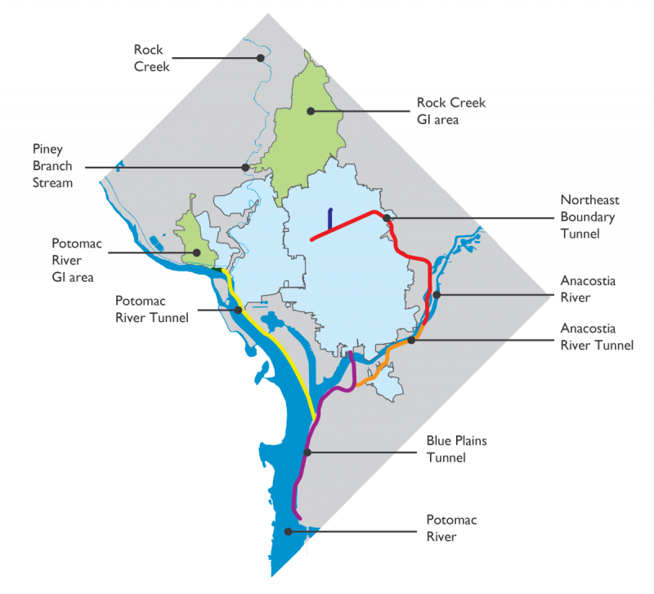
Figure 7. The Anacostia Tunnel was put into operation in March, 2018. The Northeast Boundary will receive flows in 2023 and construction of the Potomac River tunnel will be completed in March, 2030.

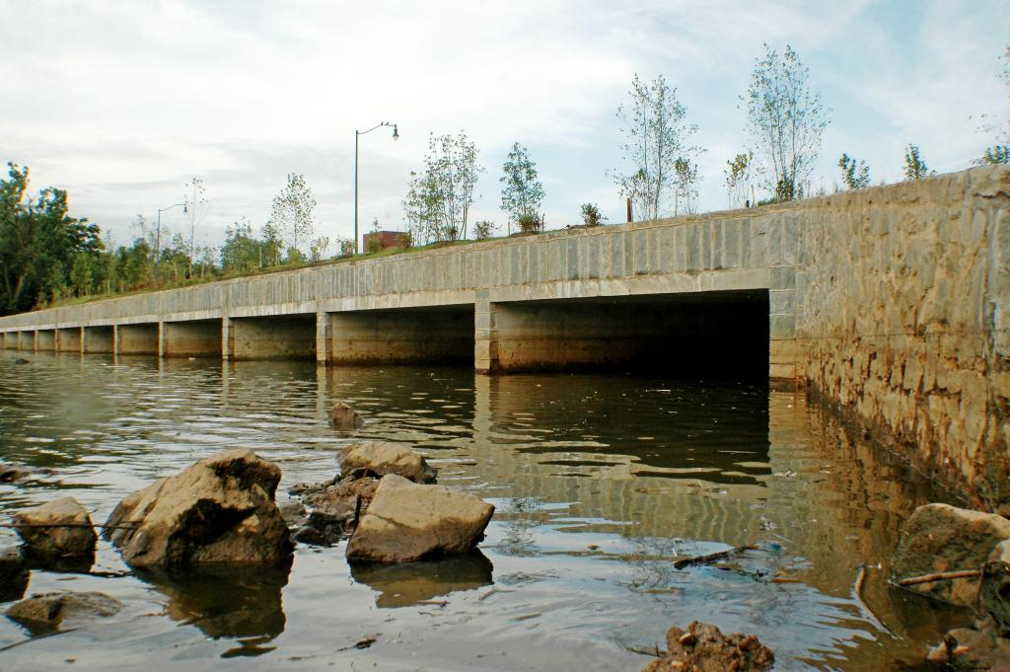
Figure 8 Constructed in 2018, this mammoth structure is the discharge point of CSO #19, the NE Boundary Sewer.

The Annual Discharge of Northeast Boundary Sewer (CSO #19)
2015-2021 (mg)

CSO | 2015 | 2016 | 2017 | 2018 | 2019 | 2020 | 2021 | Total
19 | 1012.12 | 495.49 | 881.57 | 377.93 | 45.71 | 247.61 | 54.30 | 3114.73
19a | 0 | 0 | 0 | 68.02 | 21.53 | 126.1 | 5.73 | 221.38
Total | 1012.12 | 495.49 | 881.57 | 445.95 | 67.24 | 373.71 | 60.03 | 3336.11

References
Banta W.C. 1993. Biological Water Quality of the Surface Streams of the District of Columbia. Occasional Publications, Department of Biology, American University, Washington, DC 20016. Volume 2, no. 1.

“The Big Boundary Sewer” A History of the Work – Why It Was Necessary – A Large Area To Be Drained:” Evening Star, July 26, 1881, page 1.
Capital Improvement Program, Quarterly update by Paul Gittridge before the Environmental Quality and Operations Committee, February 18, 2021. Accessed from DC Water website, February 22, 2021.

“Cleanup of Anacostia River is Fully Short of Target, New Device Culled Half of Intended Waste” Evening Start, by D’Vera Cohen, May 19, 1992

DC Citizen Science Water Quality Monitoring Report, Department of Energy and Environment (DOEE), 2020. (https://www.anacostiariverkeeper.org/wp-content/uploads/2020/11/RK-VWQM-2020-Report_Final-with-Appendix-A.pdf)

“The District Budget on Course of Preparation.” Evening Star, October 12, 1903

DC Water 2020 Budget Adopted by the Board of Directors, April 4, 2019. Accessed from DC Water.com February 18, 2021.

District of Columbia Water and Sewer Authority (WASA), 2002. Combined Sewer System Long Term Control Plan (LTCP).

“Drainage of the City” Evening Star, July 19, 1884. P. 2

Hering Report. Report upon the Sewerage of the District of Columbia. Rudolph Hering, Samuel M. Gray, Frederic F. Stearns Board of Sanitary Engineers. House of Representatives, 51st Congress, 1st session, Ex.Doc No. 445. Washington. Government Printing Office, 1890.

“The Largest Artificial Water Outlet of Its Kind in the World,” Washington Post, June 17, 1879

“The Living New Deal” https://livingnewdeal.org/projects/northeast-boundary-sewer -extension-Washington-dc/

Mayor’s Task Force on the Prevention of Flooding in Bloomingdale and LeDroit Park, Report, December, 2012.

Metagenomic Sequencing and Quantitative Real Time PCR for Fecal Pollution Assessment in an Urban Watershed.” Kyle D. Brumfield, Joseph A. Cotruvo, Orin C. Shanks, Mano Sivaganesan, Jessica Hey, Nur A. Hasan, Anwar Huq, Rita R. Colwell, and Menu B. Liddy. Waterdoi: https://doi.org/10.3389/frw2021,626849. Published February 15, 2021.

Monthly Operations Report for the Combined Sewer System. The Reports are grouped quarterly and generally available by the 15th of the month following the end of the quarter. The reports are available on DC Water's web site: DC Water.com under publications.

Report of the Operations of the Engineers, Department of Sanitary Engineering, District of Columbia Board of Commissioners Annual Report. Various years from 1874 to 1929.

“Trunk Sewer Project, Taxpayers Petition for Its Consideration, Commissioner Biddle Approves,” Evening Star, November 9, 1903.

Water Quality Assessment, 2009 and 2014 as submitted to US Environmental Protection Agency by the District of Columbia Department of Energy and the Environment.

Water Quality in the Anacostia River, Maryland and Rock Creek, Washington, DC Continuous and Discrete Monitoring with Simulations to Estimate Concentrations and Yields of Nutrients, Suspended Sediment and Bacteria by Cherie V. Miller, Jeffrey G. Charat, and Joseph Bell, MD-DE-DC Water Science Center US Geological Survey, 5522 Research Park Drive, Baltimore, MD 21228 (http://md.water.usgs.gov), 2011.

Wennersten, John R. “Anacostia: The Death and Life of an American River” The Chesapeake Book Company, Baltimore, MD 2008.

Wikipedia, accessed March 3, 2021. "Charles Carroll Glover.”

Appendix

Table A
Total Discharges from all the Anacostia CSOs Have Been Decreasing (mg)
Year | Discharge
2015 | 1444.04
2016 | 655
2017 | 1200
2018 | 636.92
2019 | 149.83
2020 | 428.06
2021 | 75.66
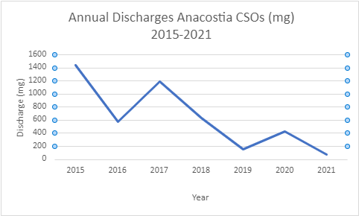

Table B
Anacostia Neighborhood CSOs Ranked by Discharge Volume 2015-2021 (mg)

CSO 19 NE Boundary | 3336.11
CSOs Main Pumping area  (CSOs 9,10,11,11a,12) | 809.46
CSOs OF Capitol East/Barney Circle (CSOs 16,17, and 18) | 217.02
CSOs of the Navy Yard (CSOs 13, 14 and 15) | 113.71
CSOs of the East Bank (CSOs 5 and 7) | 113.19

Table C
Anacostia CSOs: Drainage, Catchment Location, and Discharge (mg) 2015-2021
Outfall # | Location | Drainage (acres) | Catchment Location | Discharge (mg) 2015-2021
5 | East Bank Anacostia, Across from Navy Yard | 65.61 | Ft. Stanton | 44.86
7 | Between 11th St. and Anacostia Bridge | 188.13 | Ft. Stanton | 68.33
9 | Main Pumping/O St. | 41.27 |  | 31.19
10 | O St. Pumping | 732.72 | B St./NJ Ave. Pumped* | 554.04
11 | Main Pumping Station | 732.72 | B St./NJ Ave. Pumped | 11.66
11a | Main Pumping Station | 732.72 | B St./NJ Ave. Pumped | 5.50
12 | Main Pumping | 1,153.83 | Tiber Creek | 207.07
13 | Navy Yard/4th Street SE | 20.10 | Canal St. Sewer | 28.52
14 | Navy Yard/9th St., M St. SE | 128.06 | Navy Yard/M St SE, 6th and 7th Street | 71.29
15 | Navy Yard/9th St., M St. SE | 30.82 | Navy Yard/9th St.-M St SE | 13.90
16 | 12th and O Sts. SE | 152.58 | Navy Yard/M St SE, 12th – 9th St. SE | 41.97
17 | M and Water Sts. SE | 259.91 | Navy Yard/M St, 14th to PA Avenue SE | 107.94
18 | South of PA Ave. Bridge SE | 48.93 | Barney Circle | 67.11
19 | South RFK Stadium | 4,242.39 | NE Boundary | 3,114.73
19a | South of RFK Stadium | 4,242.39 | NE Boundary | 221.38

Table D
Anacostia CSOs: Regulator Structures, Location, and Discharge 2015-2021(mg)

CSO # | Reg Structure | location | discharge (mg)
5 | 6 | Chicago St. and Railroad Ave | 44.86
5 | 7 | W St and Railroad Ave. SE | 44.86
7 | 9 | 13th and Ridge Pl SE (Diversion Structure | 68.33
7 | 9a | 13th St and Ridge Pl SE (Regulator Structure) | 68.33
7 | 9b | 11th St Bridge and I-295 (CSO 07 Diversion Chamber) | 68.33
9 | 13 | 2nd St, 300 ft., north of N Pl, SE | 31.19
10 | 15 | South Capitol and E Sts SE | 554.04
10 | 15a | Half and L Sts | Ditto
10 | 15b | South Capitol and Eye Sts SE | Ditto
10 | 15c | South Capitol and Eye Sts SE | Ditto
11 | 12 | Storm Pump Discharge at Main Pumping Station | 11.66
11a | 14 | 2nd St. 250 ft. north of N Pl. SE | Ditto
12 | 16b | North of Main Sewage Pumping Station | 207.07
13 | 17 | 4th and N Sts. SE Both extended | 28.52
13 | 17a | K St. between 6th and 7th Sts SE (Side overflow Weir) | ditto
13 | 17b | 4th and N Sts SE, Both Extended (CSO 13 Diversion Chamber) | ditto
14 | 18 | 6th and M Sts. SE, (Diversion and Overflow Structure)t | 71.29
14 | 18ai | Tingey St. SE and 51/2 St SE(CSO-014 Diversion Chamber) | Ditto
15 | 19 | 9th and M Sts SE | 17.
15 | 19a | 9th and M Sts SE | Ditto
15 | 19b | 9th and M Sts SE (Diversion Chamber) | Ditto
15 | 19c | 9th and M Sts SE (Diversion Chamber) | Ditto
16 | 20 | 12th and M Sts. SE | 41.97
16 | 20a | 12th and M Sts | Ditto
16 | 20b | 12th and M Sts Se (CSO-16 Diversion Chamber) | Ditto
17 | 21 | 14th and M Sts SE | 107.94
17 | 21a | 14th and M Sts, SE (CSO-17 Diversion Chamber | Ditto
18 | 22a | Barney Circle and PA Ave SE | 67.11
18 | 22b | Barney Circle and PA Ave , SE | Ditto
18 | 22c | Barney Circle and PA Ave. SE | Ditto
18 | 22d | Barney Circle and PA Ave SE | Ditto
18 | 22e | 14th and KY Ave SE | Ditto
19 | 23 | Independence Ave and 21 St extended | 3,336.11
19 | 24a | East Capitol St. west of RFK Stadium | Ditto
19a | -- | -- | ditto

Table E
Anacostia CSOs By Neighborhood/Sewershed

East Bank, Anacostia River
CSO # Location
5 West Bank Anacostia, across the River from Navy Yard
7 West Bank Anacostia, between 11th St Bridge and SE Freeway Bridge

Main Pumping Station
CSO # Location
9 Main Pumping Station
10 Main Pumping Station
11 Main Pumping Station
11a Main Pumping Station
12 Main Pumping Station

The CSOs of the Navy Yard
CSO # Location
13 Navy Yard 4th St SE
14 Navy Yard, 6th St SE
15. Navy Yard and 9th Sts SE

The CSOs of Capitol East/Barney Circle

16 12th and O Sts, SE
17 M and Water Sts SE
18 South of PA Ave Bridge

Northeast Boundary CSO
CSO # Location
19 South of RFK Stadium on Service Road
19a South of RFK Stadium of Service Road
-------------------------------------------------------------------

All of these reports, plus additional background materials, are posted on my website: Wentworthgreenstrategies.com
Most historians agree that Mayor Shepard’s sewer system was a disaster. Pipes often lacked even a nod to the basic principles of hydraulics. Built to mainly satisfy his friends in the real estate industry, Shephard’s sewers typically just drained into the Washington Canal, already a dangerous fetid ditch that periodically flowed with the tides to form the malaria laden swamp flats adjacent to the present site of the Lincoln Memorial. Small wonder that many presidents decamped to higher and less dangerous suburbs especially during the dank humid days of Washington summers.
This report, required by the National Pollution Discharge Elimination System (NPDES) permit, is submitted to US EPA quarterly and available on the DC Water website.
In the early days of combined sewer construction, long before the passage of the Clean Water Act in 1972, knowledge and awareness of the problems of water pollution were considerably less than they are now. Sanitary engineers typically set CSO regulators to open when sewer flows were over one third of the flows of the receiving stream which in their mind provided adequate dilution to the pollution.
The Shepard era Board of Public Works was not known for its expertise in laying sewers. Miles of sewers were constructed to accommodate real estate developers but were found later to be badly sloped, misaligned, or simply far too small to handle the capacity demanded.
Report of the Commissioners, 1873, p. 20
Report of the Commissioners, 1874 p. 164.
Evening Star, August 4, 1883
Report of the Commissioners, 1885.
ghostsofdc.org/wp-content/uploads/suites/7/2015.10/ct004790.jpg
Report of the Commissioners, 1883
Report of the Commissioners, 1895
Commissioners, 1914, page 126.
Evening Star, “Cleanup of Anacostia River is Fully Short of Target, New Device Culled Half of Intended Waste” by D’Vera Cohen, May 19, 1992
CSOs 5,7, 15,16,17, and regulator structures have undergone extensive modification in March 2018 as part of the 11th St. Bridge construction and M St SE Diversion Project virtually eliminating discharges from those CSOs.. (more)

